Topobathymetric Model of the Coastal Carolinas, 1851 to 2020 (ver 2.0, January 2023)
Spatial Metadata Data Dictionary

Data Delivery Overview:
The geospatial data delivery consists of two geodatabases, one for each state (NC and SC). The geodatabases “Hurricane_Florence_[ST]_CoNED_TBDEM_Spatial_Metadata{_version20 for NC}.gdb” ([ST] state abbreviation; NC and SC) are geospatial polygon (Figure 1) feature datasets that contain spatial footprints for each input source dataset (Table 1). The attributes for each footprint polygon describe the characteristics of each input dataset used to generate the TBDEM. Detailed descriptions of the coordinate system, survey accuracy, and geodatabase attribute fields are contained in following sections of this document.
Table 1: Polygon Geodatabase Datasets Summary
Geodatabase – Formats include Esri File-Geodatabase (GDB) and Open Geospatial Consortium’s (OGC) open format GeoPackage (GPKG) | Layer Type | Number of Polygons+
Hurricane_Florence_NC_CoNED_TBDEM_Spatial_Metadata | Multipart Polygon | 13
Hurricane_Florence_SC_CoNED_TBDEM_Spatial_Metadata | Multipart Polygon | 24

Horizontal Coordinate System:
Transverse Mercator
NAD 1983 (2011) UTM Zone 17N
Horizontal coordinates are provided in UTM northing/easting.

Attribute Field Data Dictionary (File-Geodatabase, GeoPackage):
Title = Source dataset name
Source_Project = Organization major project or activity
Source_Organization = Source dataset organization
Data_Provider = Organization source data was acquired
Date_Acquired = Date data were acquired
Source_Publication_Date = Date source data were published
Source_Publication = Online web link to input source dataset
Data_Type = Input elevation type
Coverage_Area = General spatial extent description of input source dataset
Source_Projection = Input source projection
Source_Resolution = Input source horizontal resolution
Source_Horizontal_Datum = Input source horizontal datum
Source_Horizontal_Units = Input source horizontal units
Source_Vertical_Units = Input source vertical units
Source_Vertical_Datum = Input source vertical datum
Geoid = Input source geoid
Shape_Length* = Perimeter length of spatial polygon feature in meters
Shape_Area* = Area of spatial polygon feature in square meters

Example attributes from spatial metadata (File-Geodatabase/GeoPackage):
Title = 2018 USACE NCMP Post-Florence Topobathy Lidar (NC, SC, VA)
Source_Project = USACE NCMP
Source_Organization = USACE JALBTCX
Data_Provider = NOAA
Date_Acquired = 2018
Source_Publication_Date = 20190809 (Date format YYYYMMDD)
Source_Publication = https://coast.noaa.gov/htdata/lidar1_z/geoid12b/data/
Data_Type = Topobathy Lidar
Coverage_Area = Southern Coast (VA, NC, SC)
Source_Projection = Geographic
Source_Resolution = 1/27 arc-second (~1-m)
Source_Horizontal_Datum = WGS84
Source_Vertical_Units = Meters
Source_Vertical_Datum = NAVD88
Geoid = GEOID12B
Shape_Length* = 1345963.036692
Shape_Area* = 46842673.186489
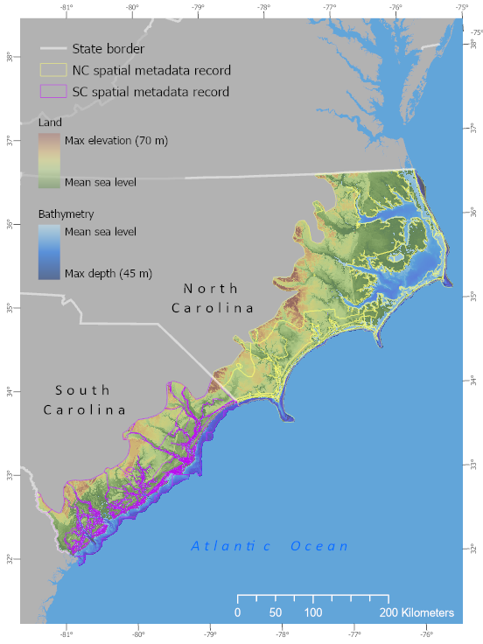
Figure 1: Spatial Metadata (SMD) extent of Hurricane Florence Coastal Carolinas, 1851 to 2022 Topobathymetric Digital Elevation Model (TBDEM). NC Spatial Metadata (SMD) polygons – Yellow boundary, and SC SMD polygons – Purple boundary.

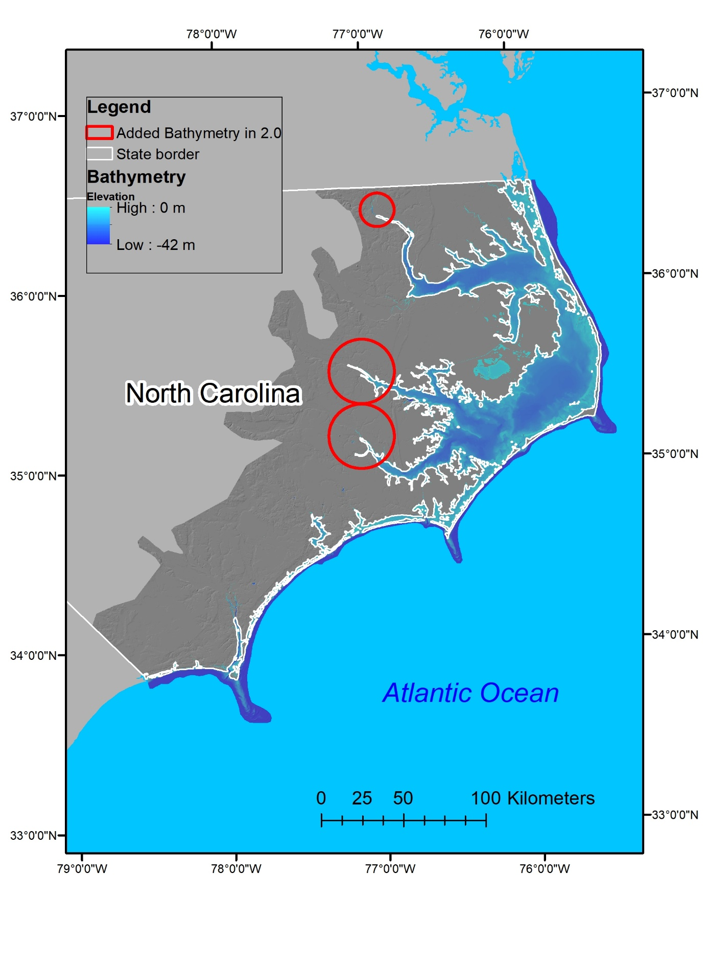
Figure 2: Red circles delineate general areas where bathymetry data have been added to version 2.0 of the TBDEM.
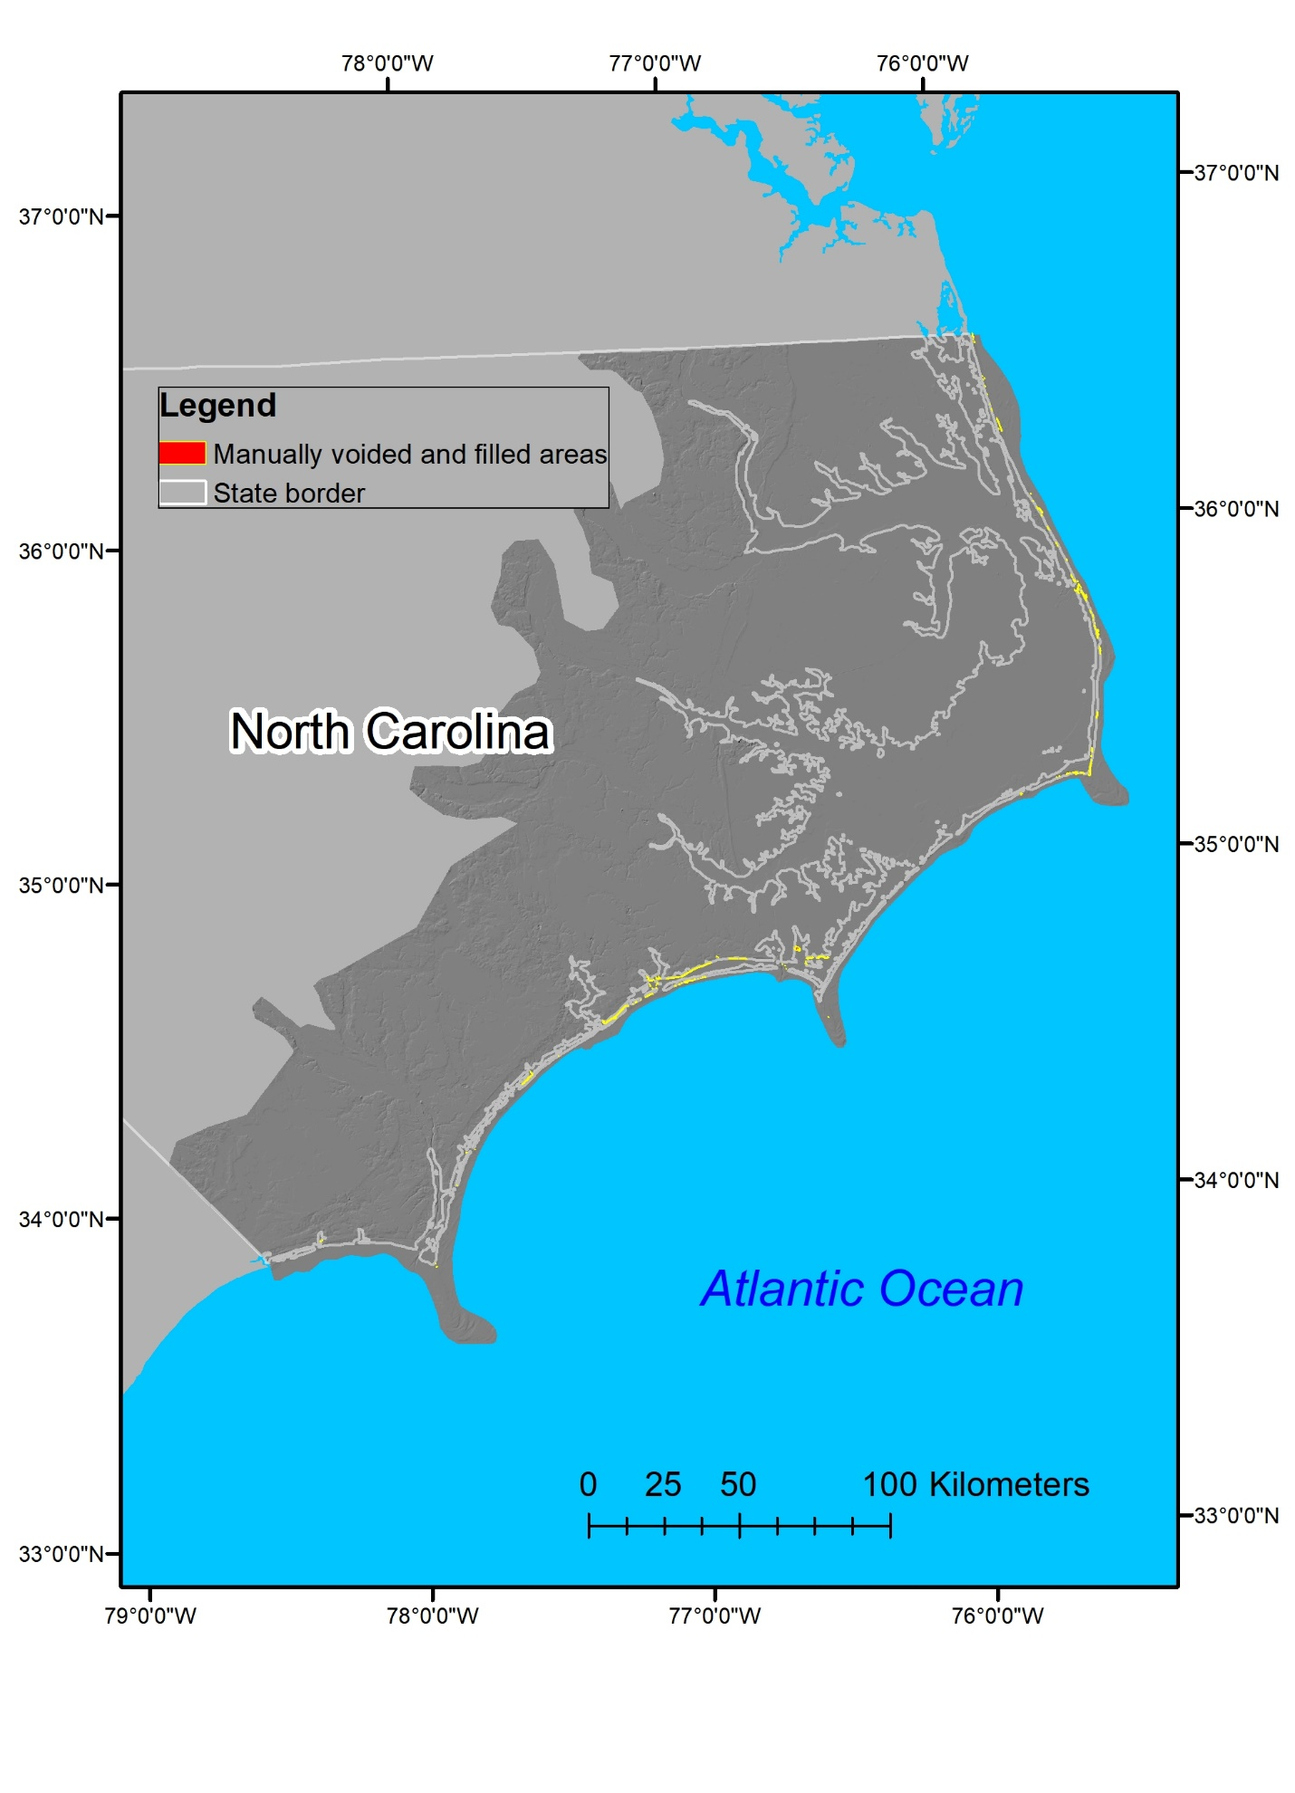
Figure 3: Red polygons with yellow outlines delineate areas that have been manually voided and refilled in version 2.0 of the TBDEM.

+ There were 28 data sources used to create these TBDEMs but the sum from the “Number of Polygons” is greater than 28 because some of the individual datasets were in both datasets.
* Inherent Esri File Geodatabase geometry attribute, these are not present in GeoPackage geodatabase Note: Any use of trade, product, or firm names is for descriptive purposes only and does not imply endorsement by the U.S. Government.

