NORTHWESTERN HAWAIIAN ISLANDS LIDAR
REPORT OF SURVEY (July 22nd-25th 2010)
(USGS Reference No. 1093630025)
The types of equipment that were used in collecting GPS data during flight and for static control are listed below.
- SOKKIA GSR 2600 WITH ATTENNA MODEL SOK600 ON KAUAI
- SOKKIA GSR 2600 WITH ATTENNA NOVATEL MODEL 207-GG ON SAND ISLAND (MIDWAY)
- SOKKIA GSR 2700ISX
The type of equipment that was used for EDM or TOTAL STATION purposes are listed below.
- SOKKIA SRX5 ROBOTIC TOTAL STATION
- 2 METER FIXED GRAPHITE ROD WITH -30MM PRISM
Listed below is a detailed time line of when and where each unit was setup. Note all measurements of GPS base stations were measured in a Slant fashion and have an offset for a vertical measurement. See Sokkia.com for factor specifications on offsets of measurements.
- July 22nd setup SOKKIA GSR 2600 WITH ATTENNA MODEL SOK600 with height of 4.73 Feet or 1.44 Meters at Lihue Airport on Kauai Hawaii on a known USGS bench mark, designation LIH R.
- July 23rd setup GSR 2600 with height of 4.90 Feet or 1.49 Meters on Midway Island on a concrete hole recognized to be where the brass cap for BM A once was. *see map below 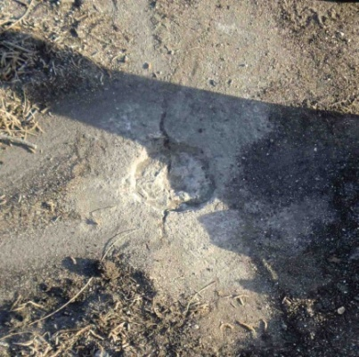

- July 24th setup GSR 2600 with height of 5.25 Feet or 1.60 Meters on Midway Island on the center of a steel tie located in the southwest corner of the inner harbor boat basin.
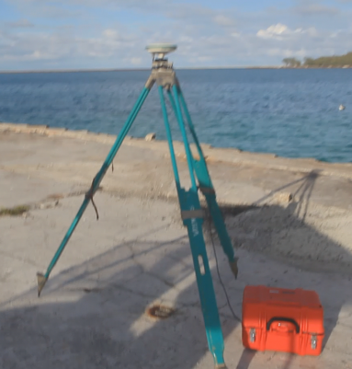

- July 25th setup GSR 2600 with height of 4.95 Feet or 1.51 Meters on Midway Island on the end of the number 2 in concrete and about 3.5 Feet from BM 19 marker 1959.
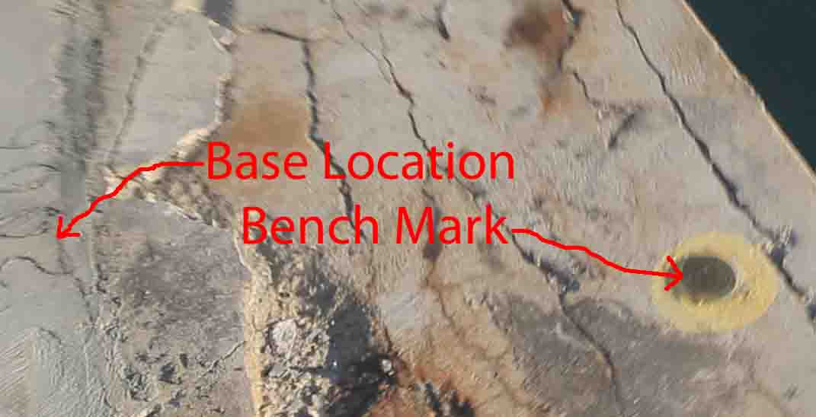

- July 25th setup the GSR 2700ISX on rod with a height of 8.70 Feet or 2.65 Meters and attached it to a golf cart and drove over the island to collect kinematic data. (See Report, Page 6) Also, setup the SRX5 TOTAL STATION on the steel tie that was used for the July 24th GPS base station and tied in the other two benchmarks that were used for the GPS base stations on July 23rd and 25th and took random ground shots on the edge of the pier and building corners.

See attachment MILP.zip for all processed base station information, kinematic data, and total station data.

Overview of Flights:
July 23rd flew over and scanned Kure Atoll & Midway Atoll:
Kure Atoll Above & Midway Atoll Below
July 24th flew over and scanned Laysan & Lisianski Islands:
Laysan Island Above & Lisianski Island Below
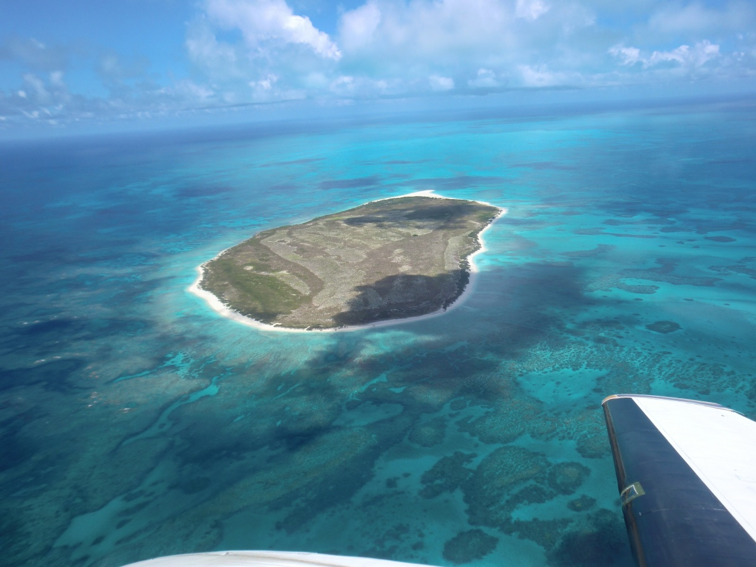
July 25th flew over and scanned the islands at Pearl & Hermes Atoll:
LiDAR scanners type 140 & 240 Riegl, camera and computer avionics, were set –up in rear of the Beechcraft Queen Air fixed wing aircraft. Camera is mounted under operator’s seat.
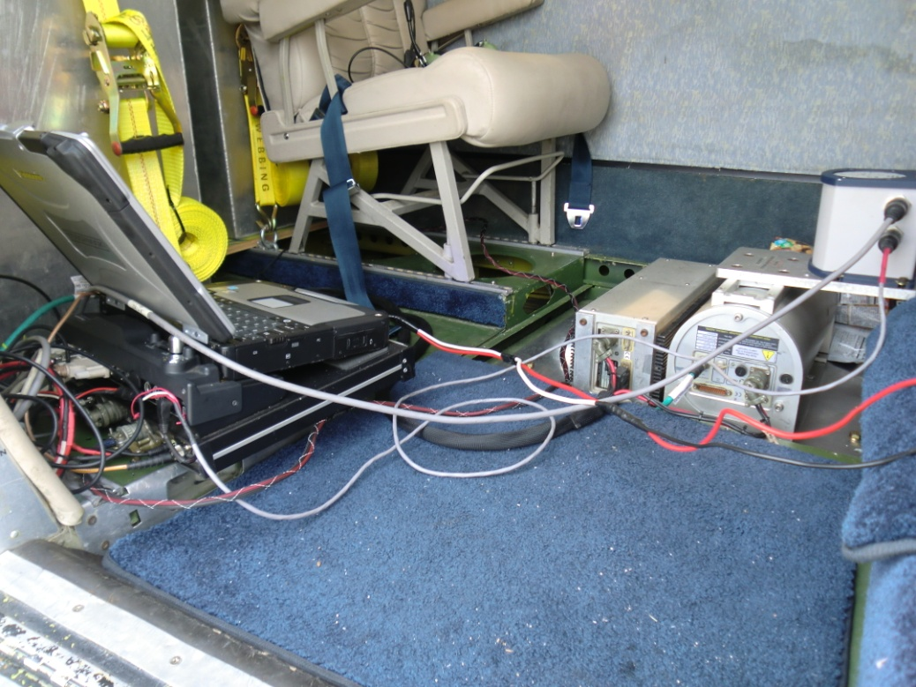

Comparison Report of LiDAR Bare Earth Model with Kinematic Ground Control
Midway Island

Methodology
In order to compare the LiDAR surface model with a kinematic ground survey the following methods and procedures were used.
A dual frequency GPS receiver and antenna are mounted on the ground unit (it this case a small “golf cart”) and the antenna height is measured to the ground. The survey is performed by driving the unit on any available roads or trails in the project area with LiDAR coverage. A dual frequency receiver is also simultaneously logging at half second or higher sampling on the same location as used for the LiDAR post processing. The resulting dataset is post processed using Waypoint’s “Gravnav” post processing software. The resulting output is sorted by estimated quality and velocity. Only points that have passed a rigorous quality control and were recorded while the ground vehicle was moving are used for the comparison. As the kinematic data is often recorded in less than ideal conditions (multipath caused by vegetation and buildings, etc.) this eliminates as many outlying points as possible for the comparison and yields a high number of high quality kinematic “control” points. This procedure is most cases is superior to a small number or static control points as it provides a comparison over a larger number of flight lines.
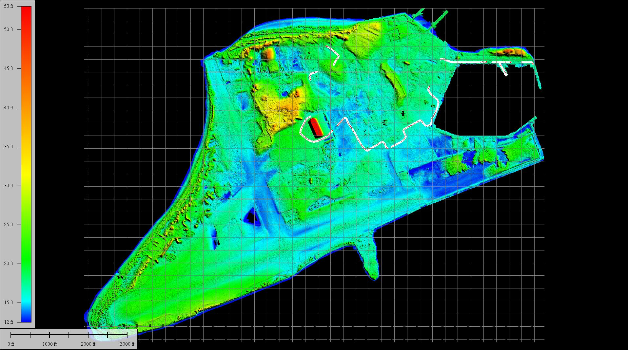
Figure 1 Midway Island Kinematic Survey

Comparison Results
The kinematic ground survey consists of 1678 points.
Note: Results in meters.
Average dz +0.032
Minimum dz -0.143
Maximum dz +0.198
Average magnitude 0.041
Root mean square 0.051
Std deviation 0.040

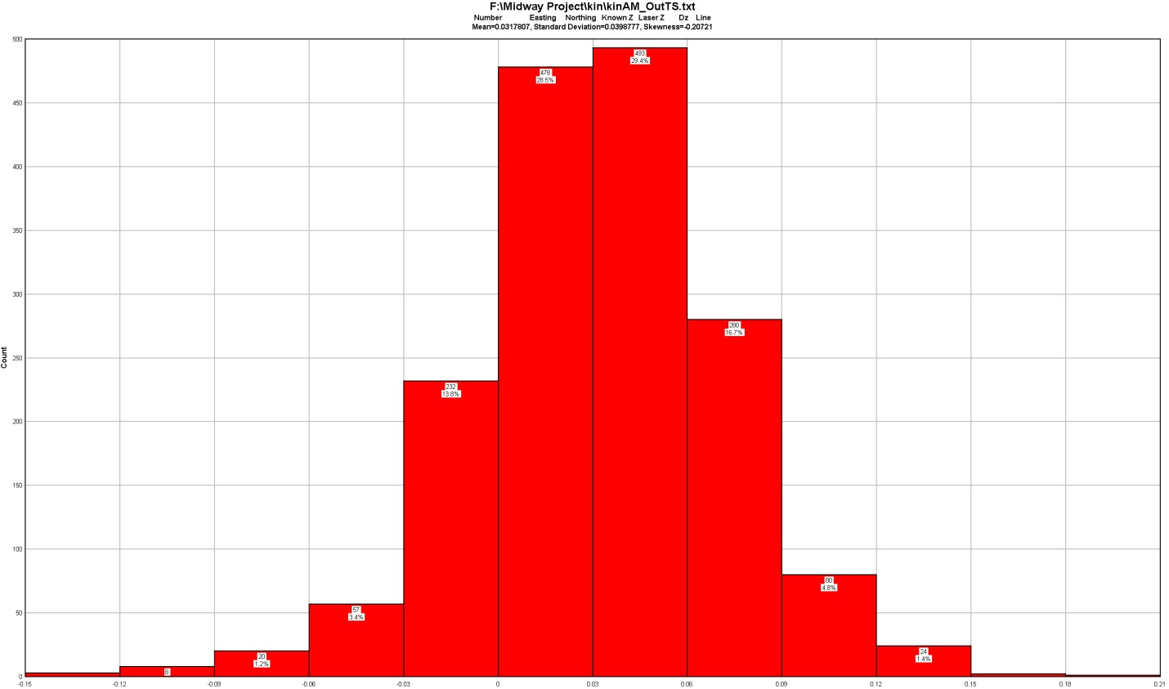
Figure 2 Comparison all Q1 Kinematic Points

The comparison shows a slight positive bias on the LiDAR surface. This is most likely caused by minor inaccuracies on the LiDAR system lever arms as these measurements can be extremely difficult to measure precisely depending on the aircraft the system is installed in.
The LiDAR surface was then shifted vertically by the average Dz for comparison purposes. The results follow:
Average dz +0.002
Minimum dz -0.173
Maximum dz +0.168
Average magnitude 0.031
Root mean square 0.040
Std deviation 0.040

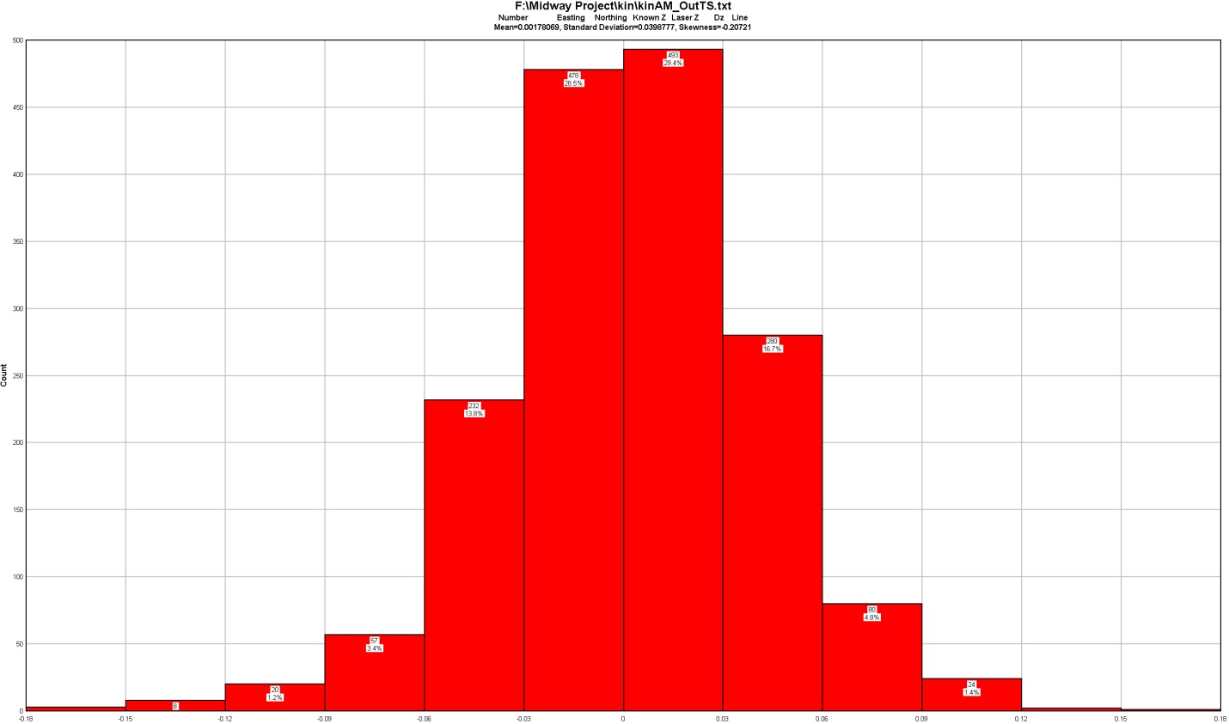
Figure 3 Comparison All Q1 Kinematic Points LiDAR Surface shifted -0.0318m

Conclusion
The LiDAR surface compares extremely well to the ground kinematic surface and yields an RMSE of 4cms or 0.131 of a foot.
REPORT BY

73-5618 Maiau Street  Unit B104
Kailua-Kona  Hawaii  96740

Thomas Pattison Hawaii Licensed Professional Surveyor No. 10743
Phone 808-327-9439
See us @ aerialsurveyinginc.com

