

Valdez, AK
Post-Flight Aerial Acquisition
Report

October 2012

Contents
1.0 Overview 4
1.1 Vendor Contact Information 4
1.2 Purpose 4
2.0 Acquisition 5
2.1 System Parameters 5
2.2 Base Station Information 5
2.3 Time Period 7
3.0 LiDAR Processing 8
3.1 ABGPS and IMU Processing 8
3.2 Initial LiDAR Processing and Calibration 21
3.3 LiDAR Calibration 23
3.4 LIDAR Processing 23
4.0 Final Accuracy Assessment 24
Appendix A: Condensed Flight Logs 25
M092111A 25
M092611A 26
M092611B 27
M101811A 28
M102811A 29
20120618_180013 30

Tables
1.1 Valdez Project Area 5
2.1 LiDAR System Specifications 5
2.2 Base Station Locations 6
2.3 Acquisition Flight Summary 7
4.1 Internal QC Control Results 24

Figures
1.1 Valdez Coverage Area 4
2.1 Base Station Locations 6
2.2 Flight Line Layout 7
3.1 Separation Plot M092111A 9
3.2 Separation Plot M092611A 9
3.3 Separation Plot M092611B 10
3.4 Separation Plot M101811A 10
3.5 Separation Plot M102811A 11
3.6 Separation Plot 20120618_180013 11
3.7 Altitude Plot M092111A 12
3.8 Altitude Plot M0926111A 12
3.9 Altitude Plot M092611B 13
3.10 Altitude Plot M101811A 13
3.11 Altitude Plot M102811A 14
3.12 Altitude Plot 20120618_180013 14
3.13 PDOPPlot M092111A 15
3.14 PDOP Plot M092611A 15
3.15 PDOP Plot M092611B 16
3.16 PDOP Plot M101811A 16
3.17 PDOP Plot M102811A 17
3.18 PDOP Plot 20120618_180013 17
3.19 Distance from Base Plot M092111A 18
3.20 Distance from Base Plot M092611A 18
3.21 Distance from Base Plot M092611B 19
3.22 Distance from Base Plot M101811A 19
3.23 Distance from Base Plot M102811A 20
3.24 Distance from Base Plot 20120618_180013 20
3.25 POSProc Processing Components 22
3.26 Example Dz Ortho 23

1.0 Overview

1.1 Vendor Contact Information

Questions regarding the technical aspects of this report should be addressed to :
AeroMetric, Inc.
Attn: Jason Mann
2014 Merrill Field Drive
Anchorage, AK 99501

Phone: 907-272-4495
Email: jmann@aerometric.com

1.2 Purpose
Aero-Metric, Inc. acquired highly accurate Light Detection and Ranging (LiDAR) data for an area that consisted of approximately 31 square miles in Valdez, Alaska. This area was a part of the Prince William Sound, Alaska project. This data was collected for STARR as a part of the FEMA Risk MAP program. A graphic of the location is provided in Figure 1.1.

The project area was defined in July 2011 in collaboration with FEMA Region X to provide high quality topographic data for two polygons.

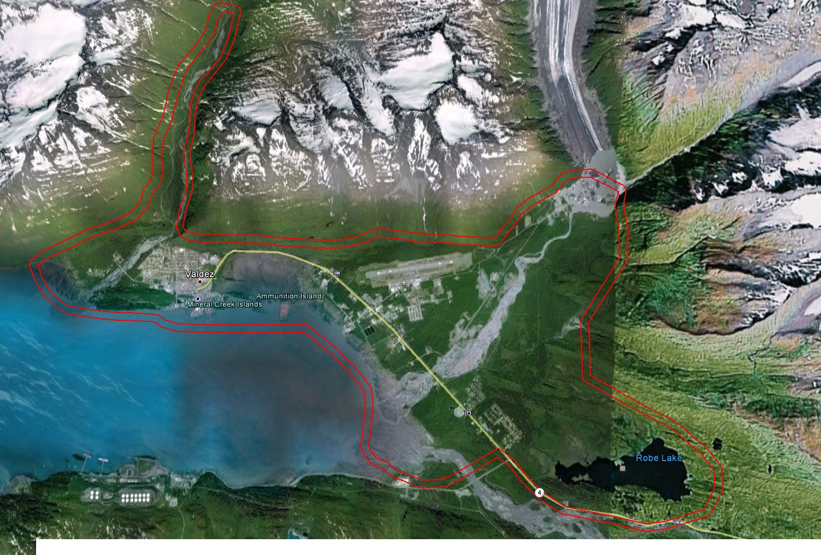
Figure 1.1: Valdez Coverage Area

North | 61° 11’49’’ N | 146° 20’23’’ W
East | 61° 05’13’’ N | 146° 05’36’’ W
South | 61° 04 14’’ N | 1146° 07’56’’ W
West | 61° 08’03’’ N | 146°26’18’’ W

Table 1.1: Valdez Project Extents

2.0 Acquisition

2.1 System Parameters
LiDAR was collected to the 'Highest' FEMA specification which is equivalent to the 2-foot contour accuracy requirement. This requires a nominal post spacing of 1 meter. The LiDAR system parameters to meet this requirement are found in Table 2.1.

Aircraft | Piper Navajo N812T and Piper Navajo N6GR
Flying Height (AGL) | 1700 meters
Laser Pulse Rate | 70 kHz
Mirror Scan Frequency | 70 Hz
Scan Angle | (+/-) 10º
Side Lap | 67%
Number of Flight Lines | 120
Flight Line Spacing | 304.98 meters
Flight Line Coverage | 64.74 sq. km.
Ground Speed | 140 - 160 knots
Nominal Point Density | 8 points per square meter per pass
Datums | NAD83
Datums | NAVD88 via Geoid09 (feet)
Projection | Universal Transverse Mercator (UTM) Zone 6N

Table 2.1 LiDAR System Specifications

2.2 Base Station Information

Base Station Information: All missions were processed using base stations located at the Valdez airport.. Table 2.2 and Figure 2.1 provide the base station location information..

POINT | LAT | LONG | HEIGHT (Ellipsoid)
45652650 | 61°07’55.74551” | 146°14’18.26593” | 44.372m
83682650 | 61°07’55.88430” | 146°14’16.92884” | 44.663m
19112910 | 61°07’55.88496” | 146°14’16.93058” | 44.661m
45652910 | 61°07’55.74544” | 146°14’18.26743” | 44.389m

Table 2.2: Base Station Location

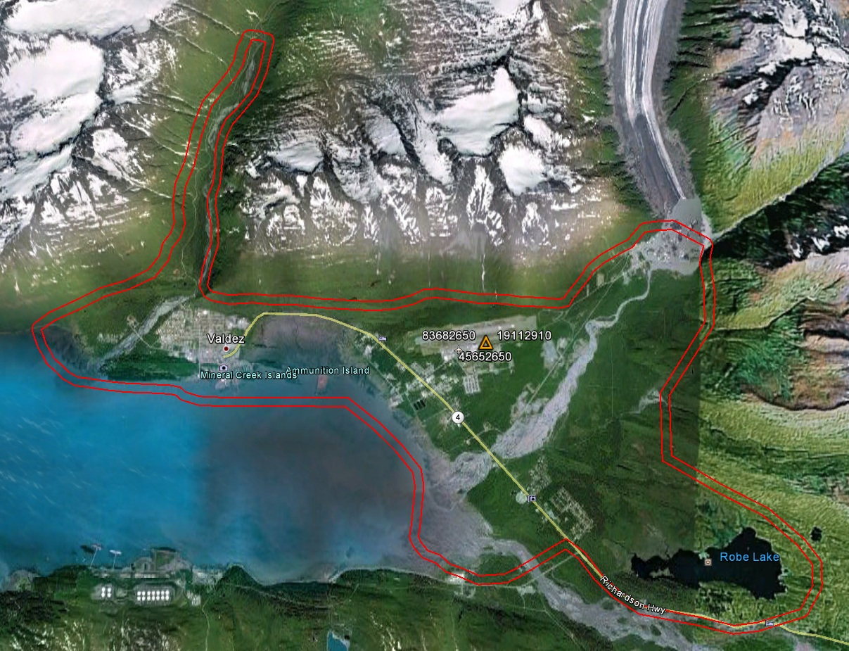

Figure 2.1: Base Station Location

2.3 Time Period
LiDAR data acquisition for the project had to be collected at two different times. First was collected between September 21, 2011 and October 28, 2011 in total of five (5) flight missions. A second collection was need to fill in the middle of the project area and (1) one mission was collected on June 18, 2012.

Acquisition Date | Mission | Time | Lines Acquired
20110921 | M092111A | 00:55-02:55 UTM | lines 19-36
20110926 | M092611A | 18:40-21:07 UTM | lines 97-120
20110926 | M092611B | 23:45-03:12 UTM | lines 1-18, 70,78-96
20111018 | M101811A | 18:47-21:49 UTM | lines 37-61
20111028 | M102811A | 20:29-23:01 UTM | lines 44-59, 35-37, 77
20120618 | 120618_180013 | 18:04-19: UTM | lines 1-13

Table 2.3: Acquisition Flight Summary

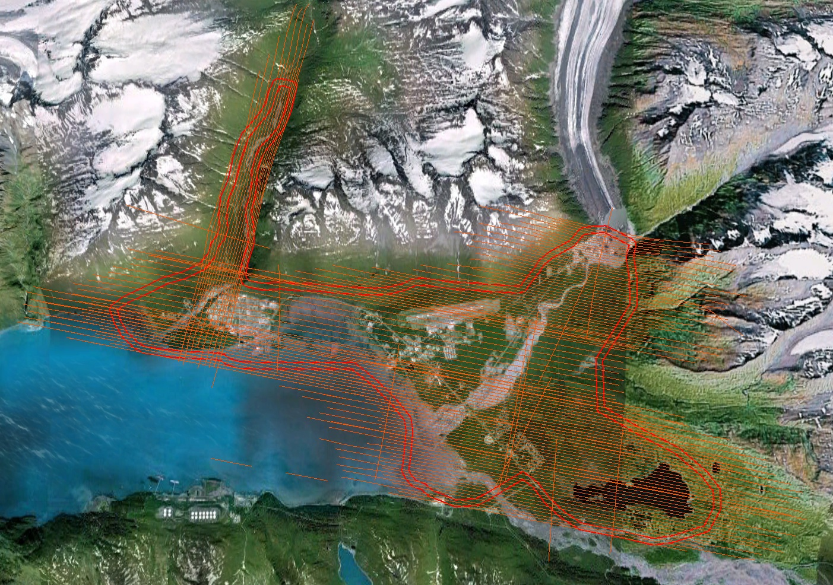
Figure 2.2: Flight Line Layout

3.0 LiDAR Processing

3.1 ABGPS and IMU Processing

Applanix - POSGNSS
Utilizing carrier phase ambiguity resolution on the fly (i.e., without initialization), the solution to sub-decimeter kinematic positioning without the operational constraint of static initialization as used in semi-kinematic or stop-and-go positioning was utilized for the airborne GNSS post-processing.
The processing technique used by Applanix, Inc. for achieving the desired accuracy is Kinematic Ambiguity Resolution (KAR). KAR searches for ambiguities and uses a special method to evaluate the relative quality of each intersection (RMS). The quality indicator is used to evaluate the accuracy of the solution for each processing computation. In addition to the quality indicator, the software will compute separation plots between any two solutions, which will ultimately determine the acceptance of the airborne GNSS post processing.
Inertial Data
The post-processing of inertial and aiding sensor data (i.e. airborne GNSS post processed data) is to compute an optimally blended navigation solution. The Kalman filter-based aided inertial navigation algorithm generates an accurate (in the sense of least-square error) navigation solution that will retain the best characteristics of the processed input data. An example of inertial/GNSS sensor blending is the following: inertial data is smooth in the short term. However, a free-inertial navigation solution has errors that grow without bound with time. A GNSS navigation solution exhibits short-term noise but has errors that are bounded. This optimally blended navigation solution will retain the best features of both, i.e. the blended navigation solution has errors that are smooth and bounded.
The resultant processing generates the following data:
- Position: Latitude, Longitude, Altitude
- Velocity: North, East, and Down components
- 3-axis attitude: roll, pitch, true heading
- Acceleration: x, y, z components
- Angular rates: x, y, z components

GPS Separation Plots

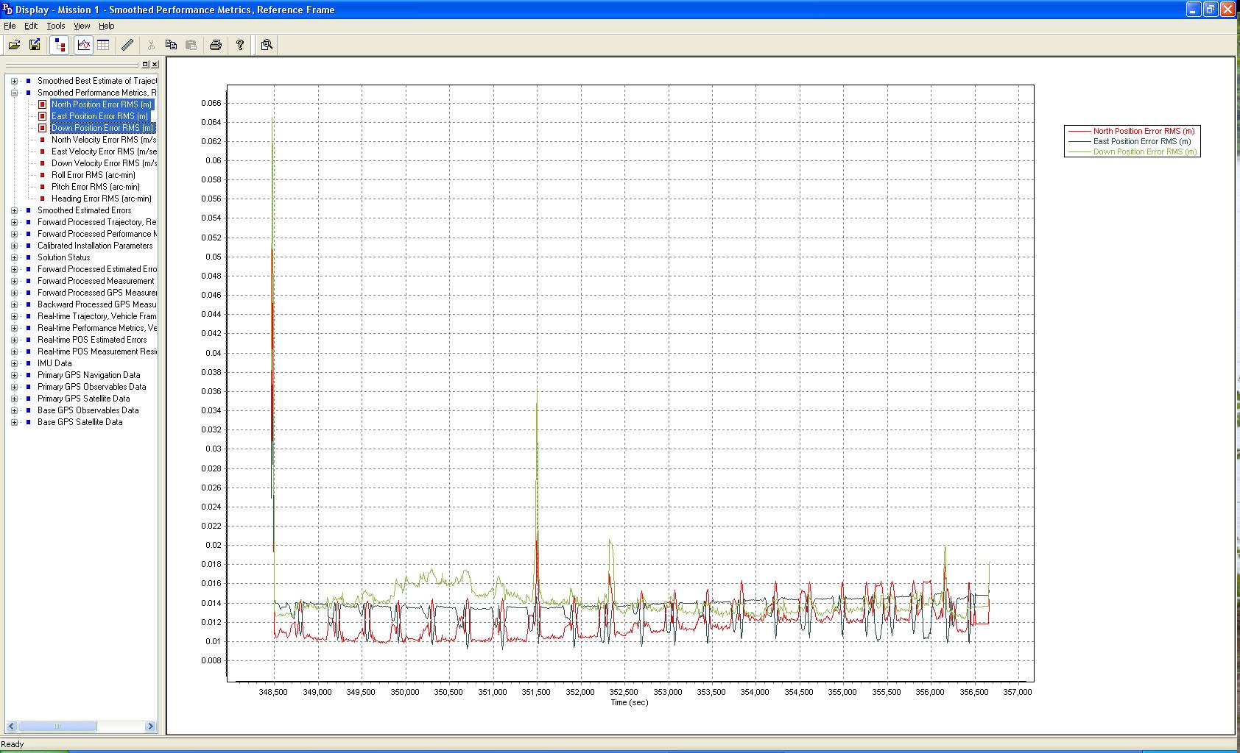

Figure 3.1: Separation Plot M092111A

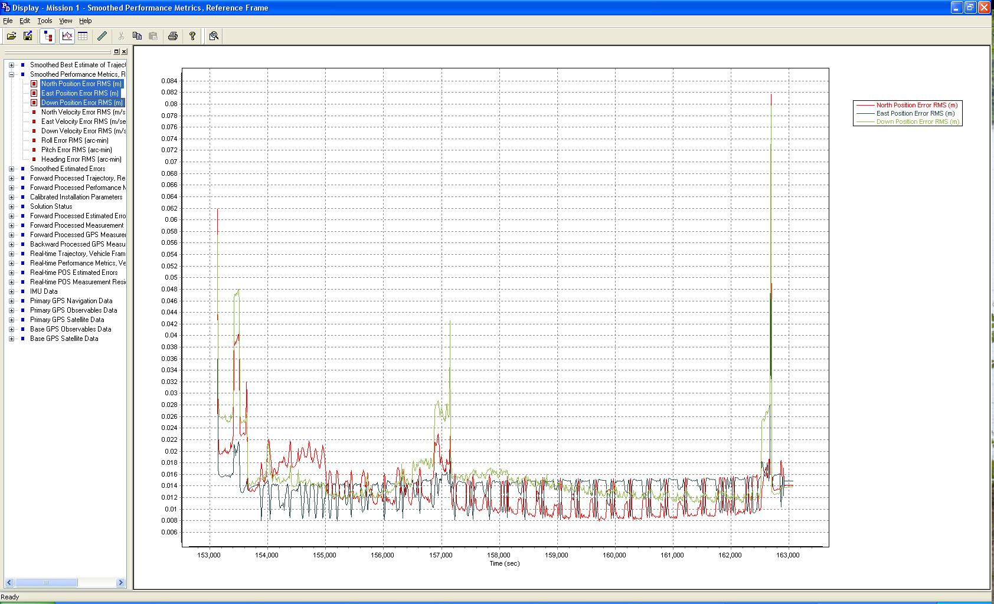

Figure 3.2: Separation Plot M092611A

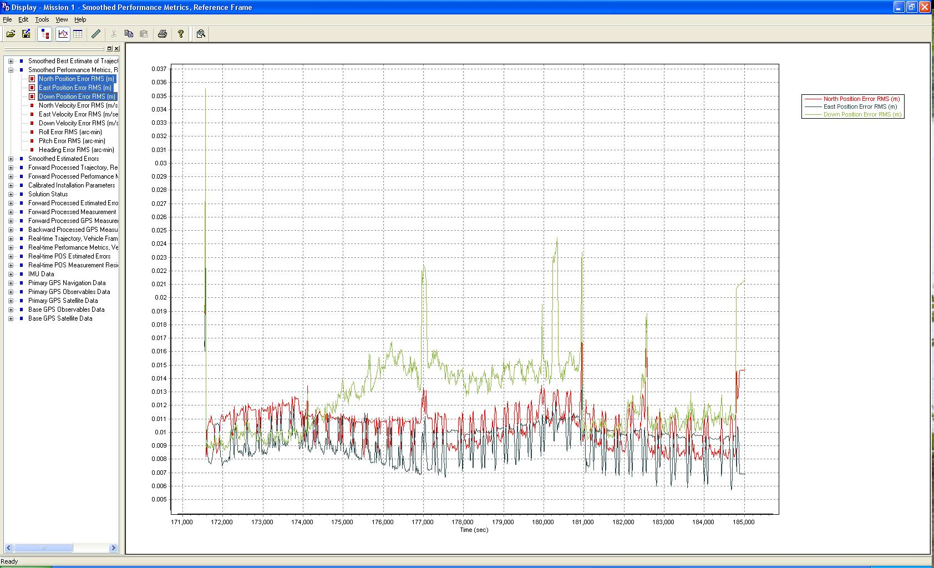

Figure 3.3: Separation Plot M092611B

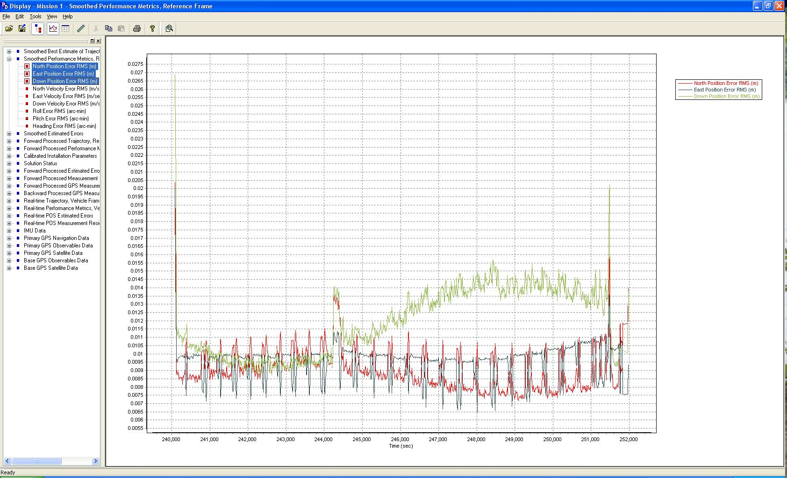

Figure 3.4: Separation Plot M101811A

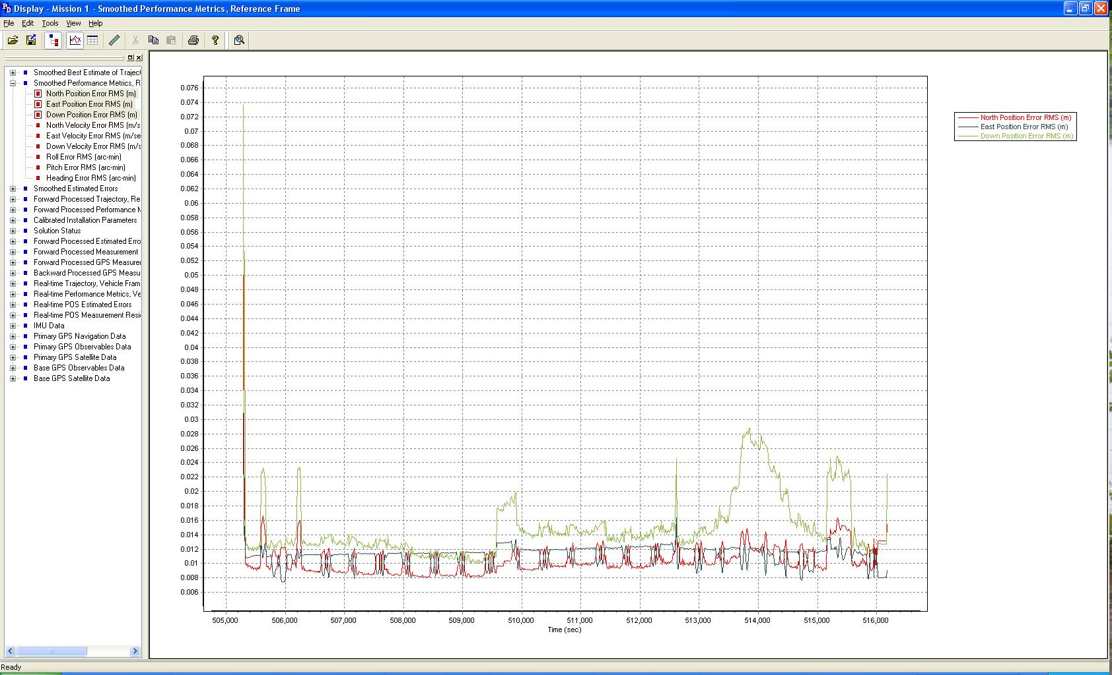

Figure 3.5: Separation Plot M102811A

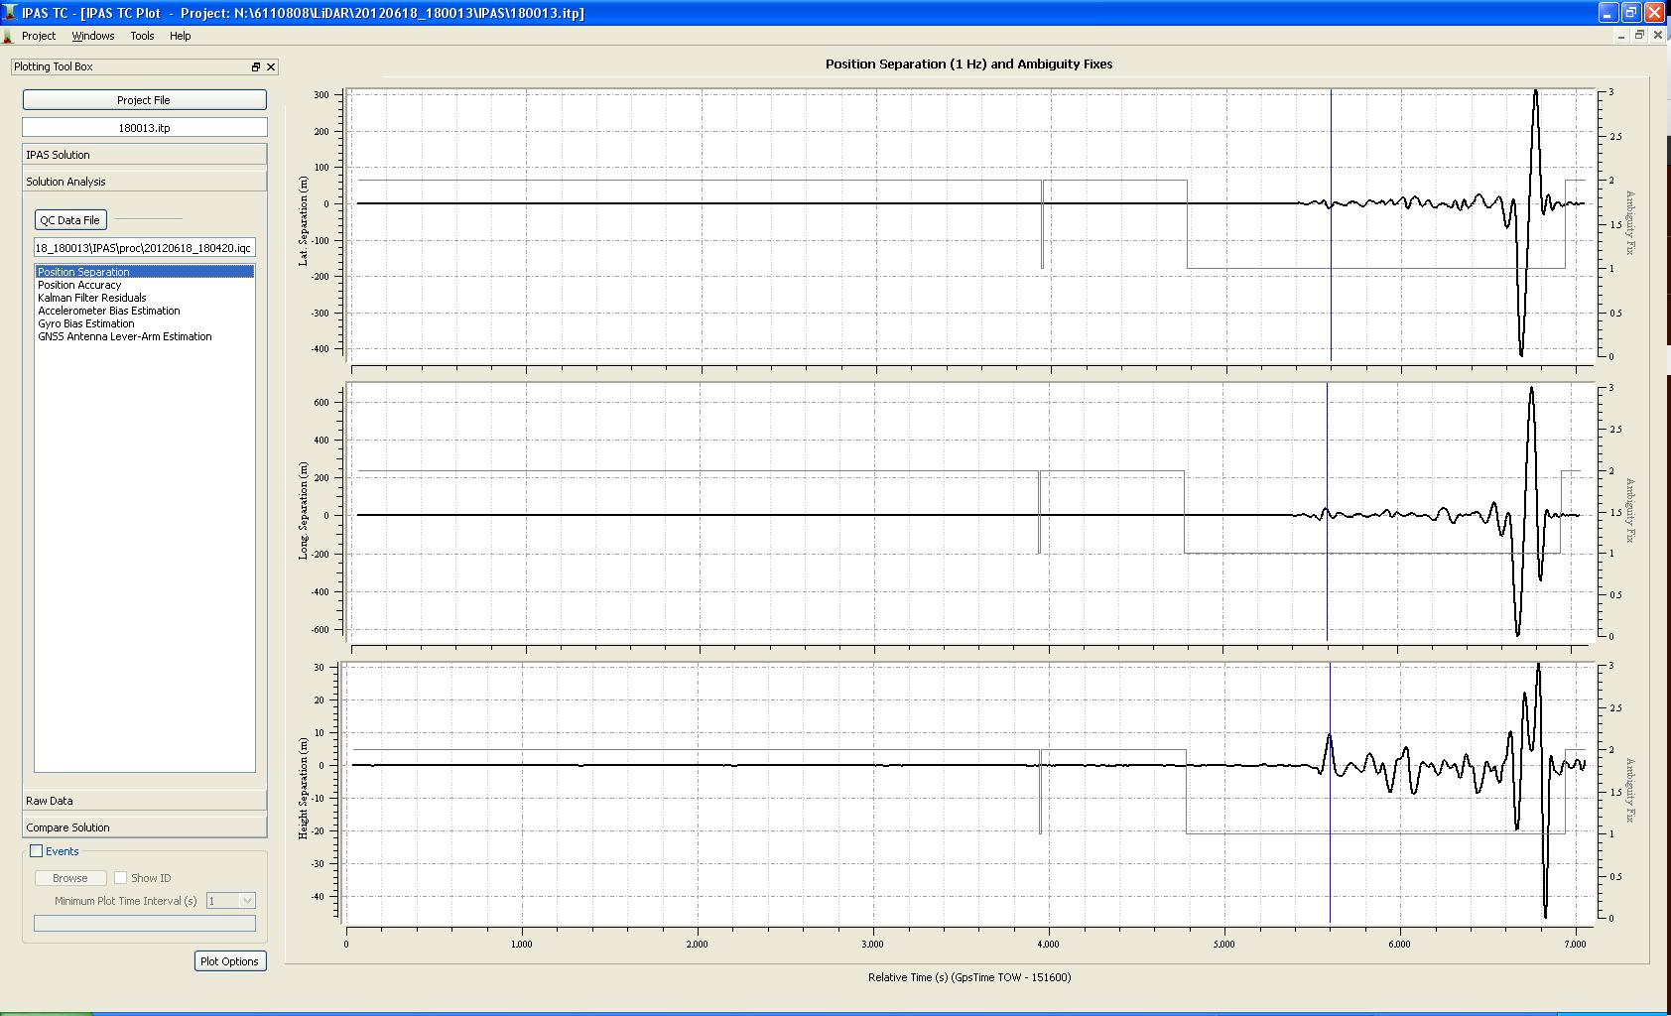

Figure 3.6: Separation Plot 120618_180013

GPS Altitude Plots

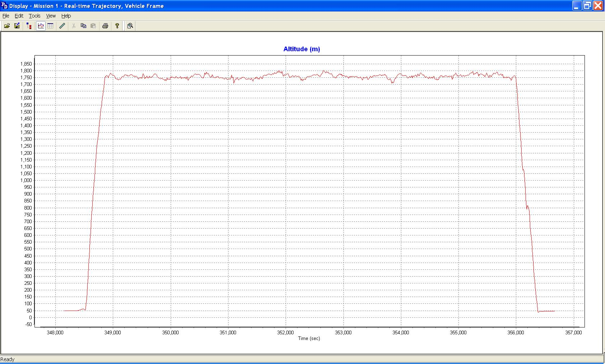

Figure 3.7: Altitude Plot M092111A

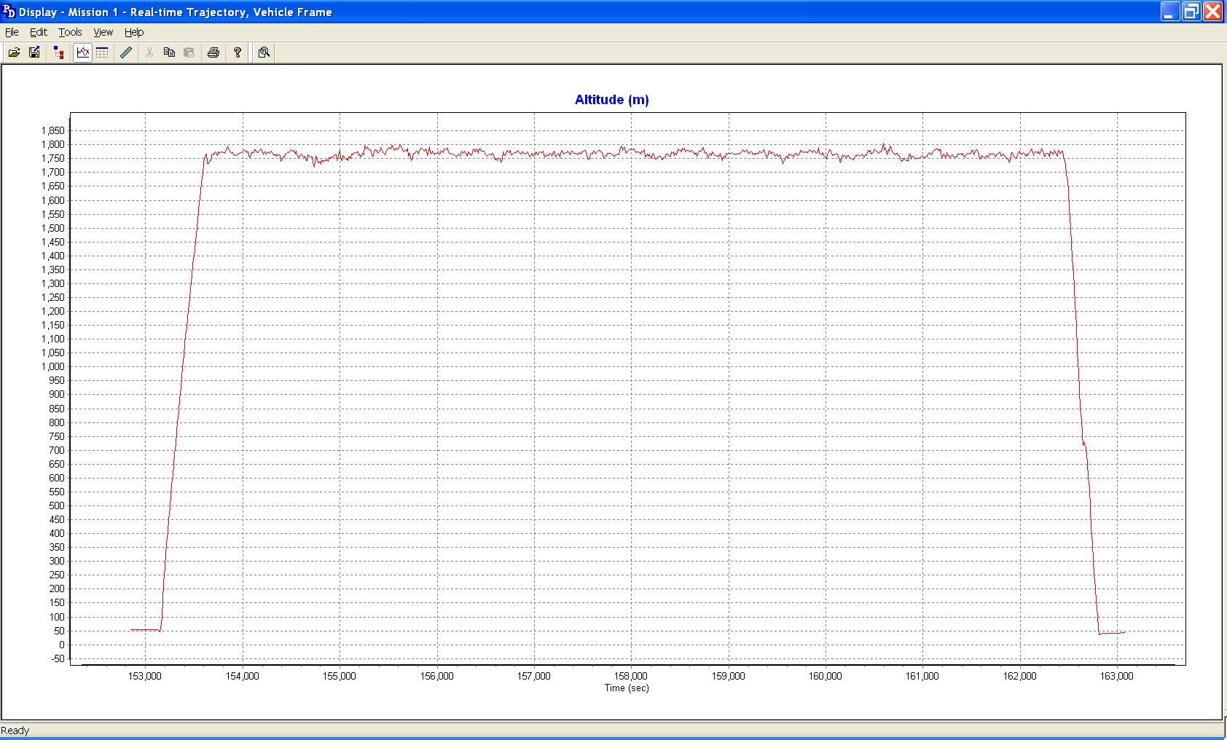

Figure 3.8: Altitude Plot M092611A

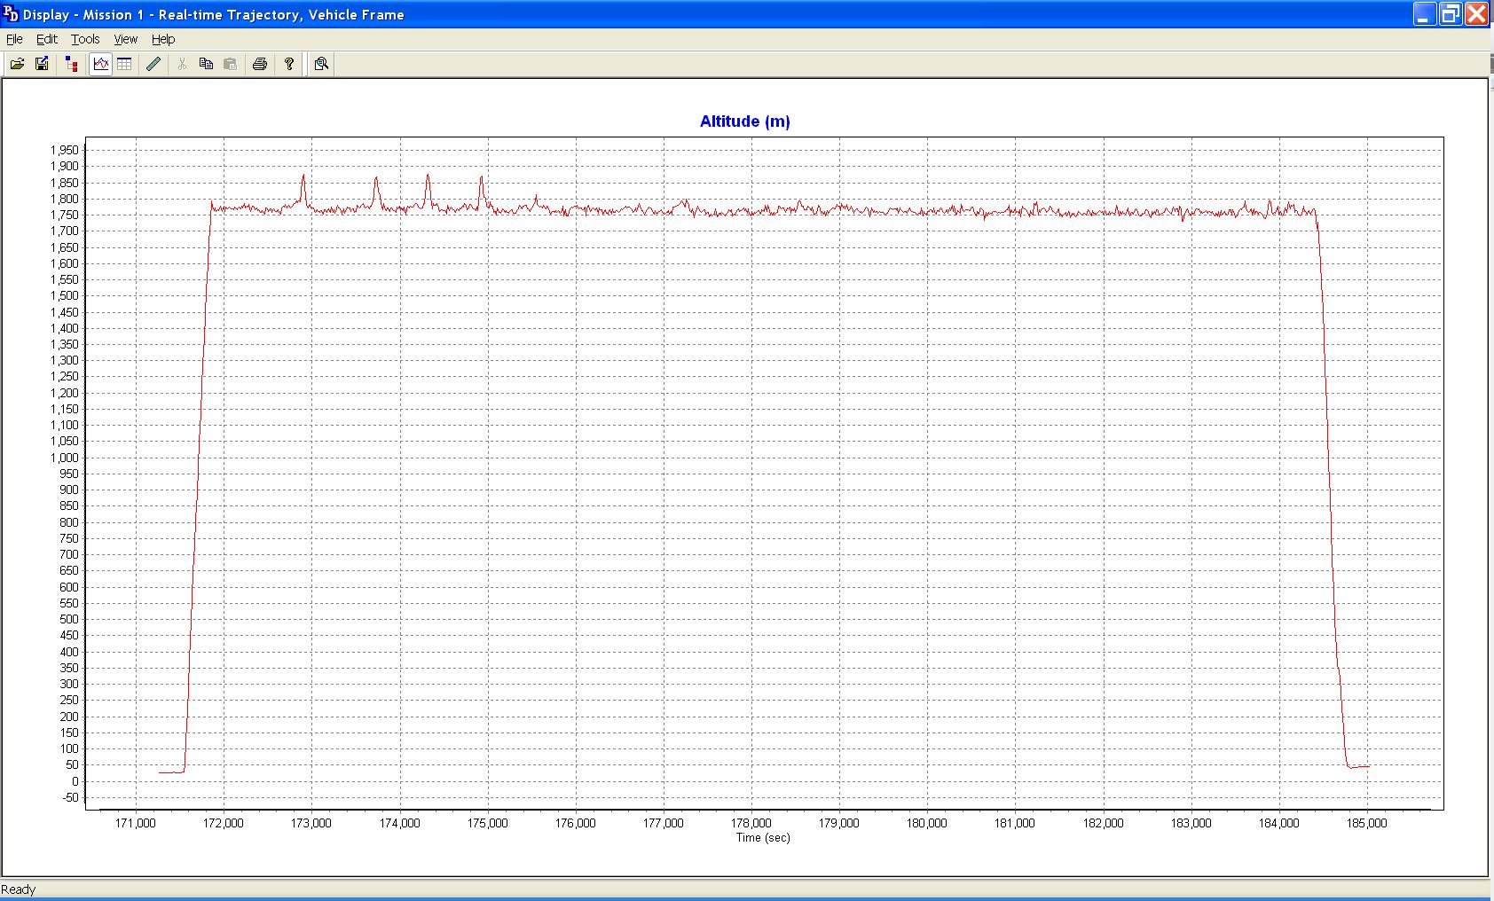

Figure 3.9: Altitude Plot M092611B

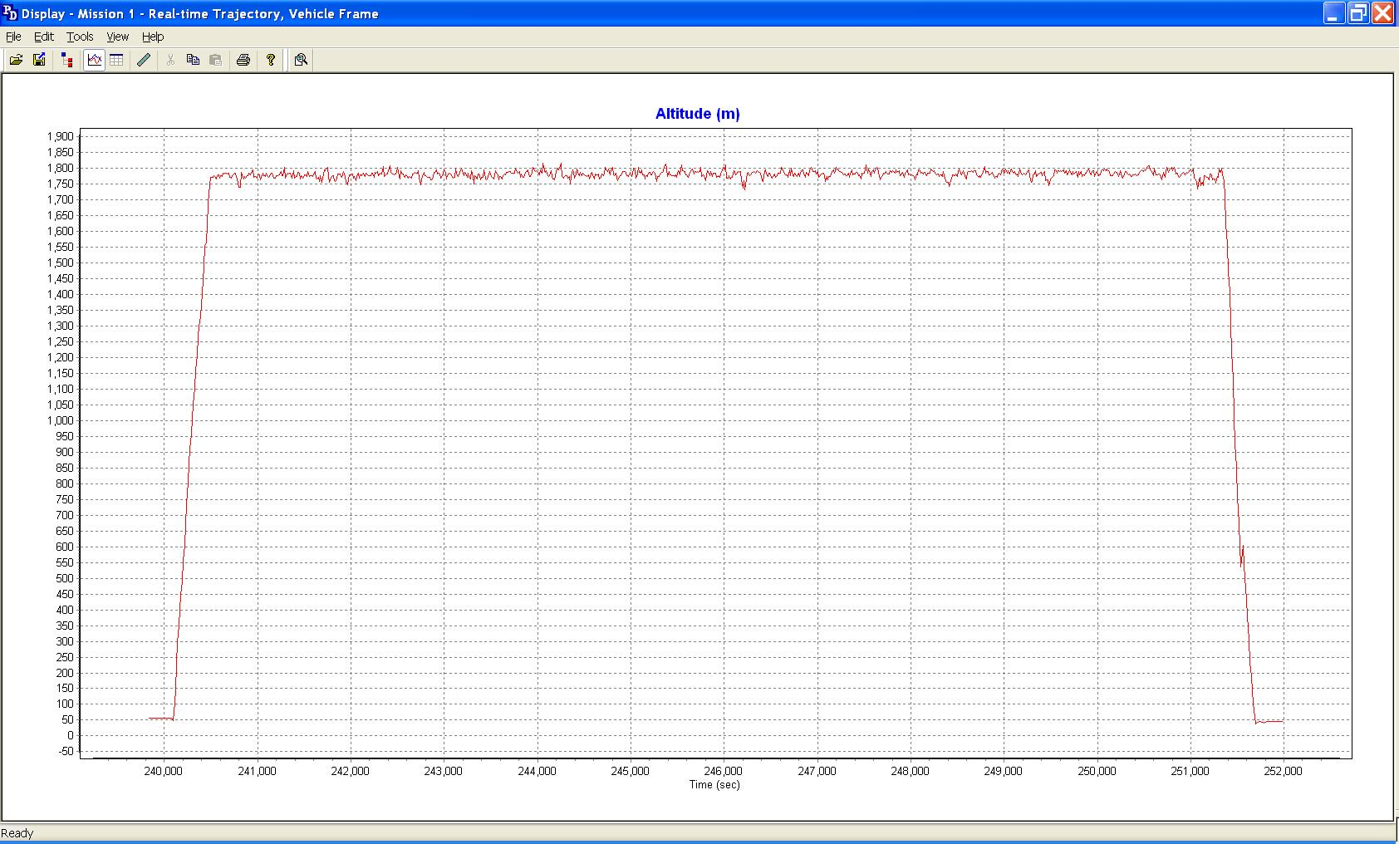

Figure 3.10: Altitude Plot M101811A

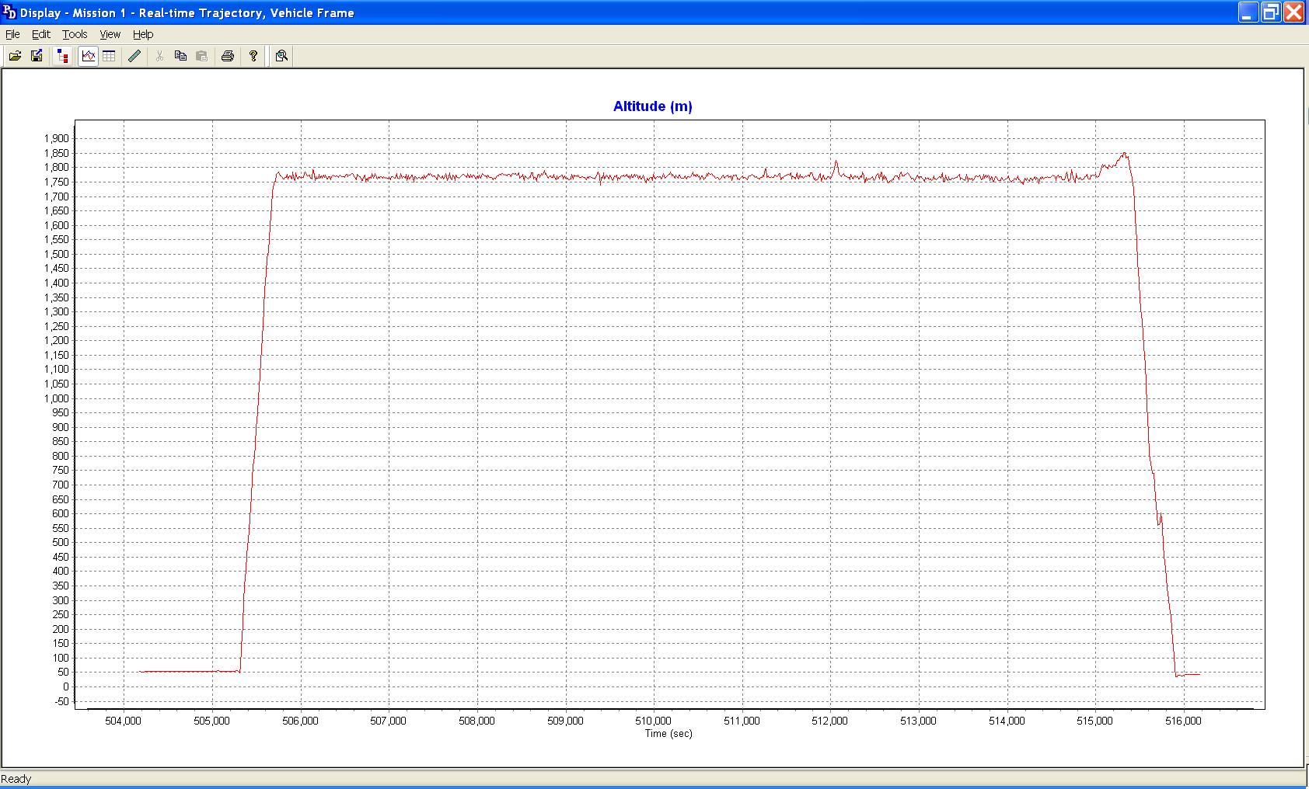

Figure 3.11: Altitude Plot M102811A

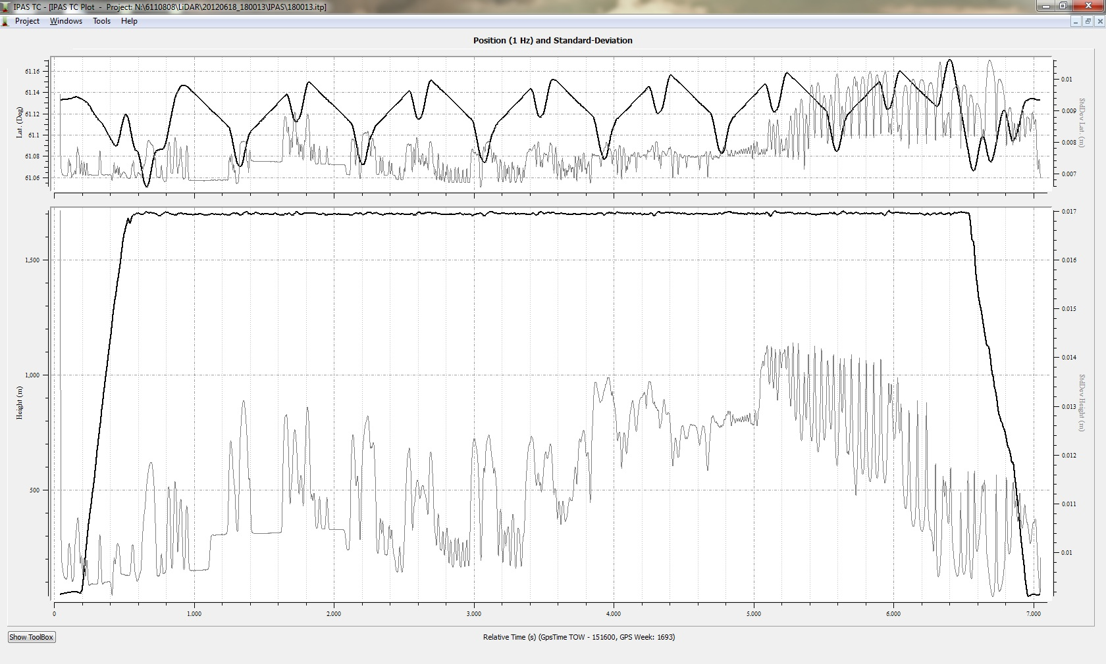
Figure 3.12: Altitude Plot 120618_180013

GPS PDOP Plots

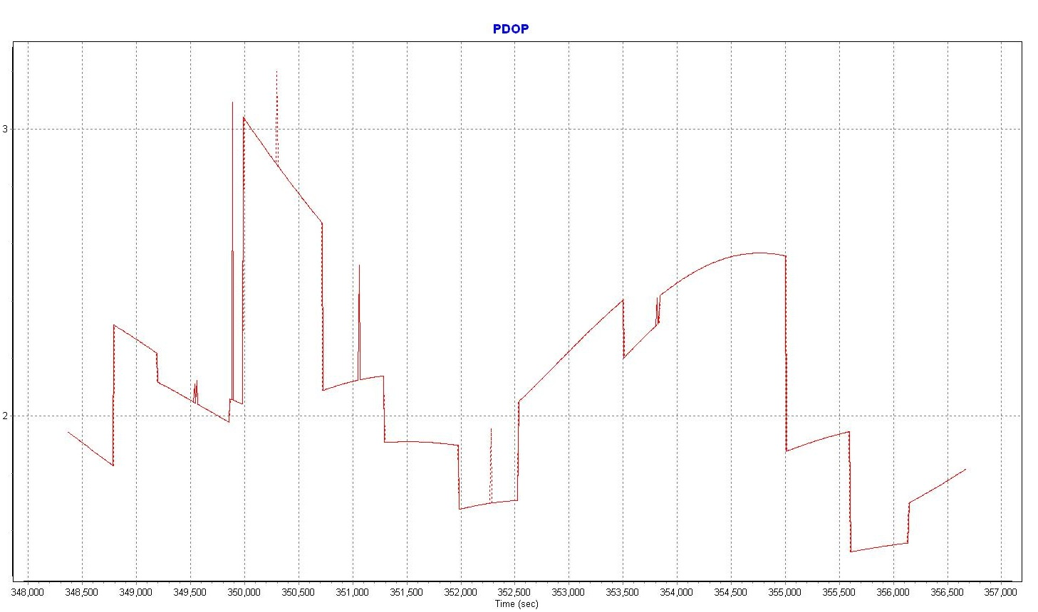

Figure 3.13: PDOP Plot M092111A

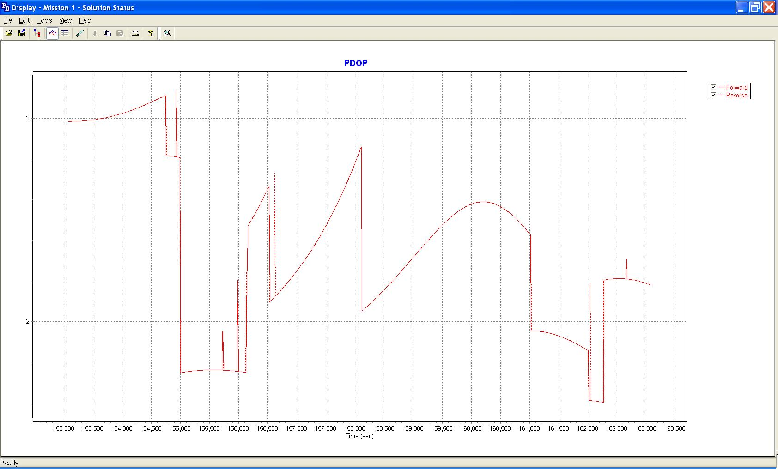

Figure 3.14: PDOP Plot M092611A

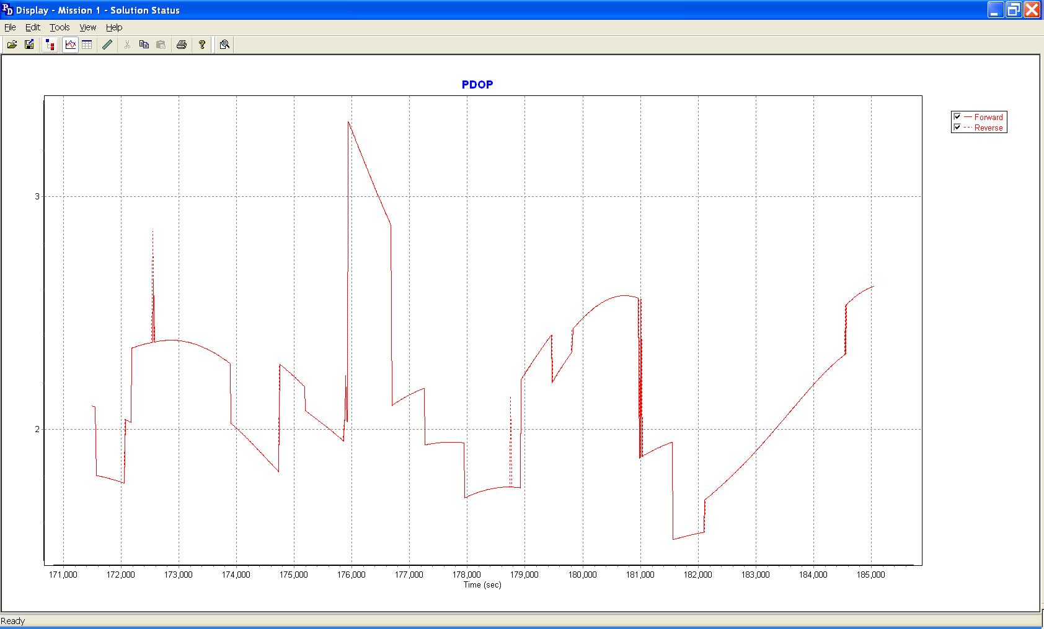

Figure 3.15: PDOP Plot M092611B

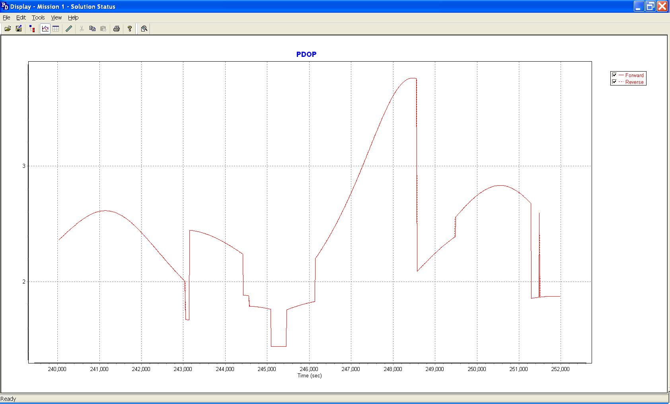

Figure 3.16: PDOP Plot M101811A

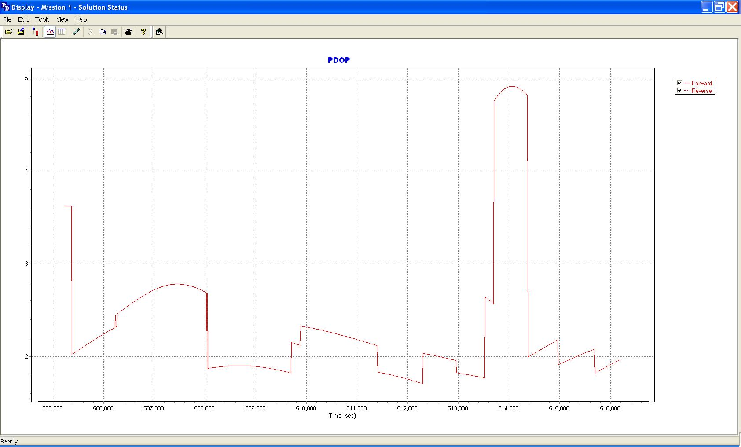

Figure 3.17: PDOP Plot M102811A

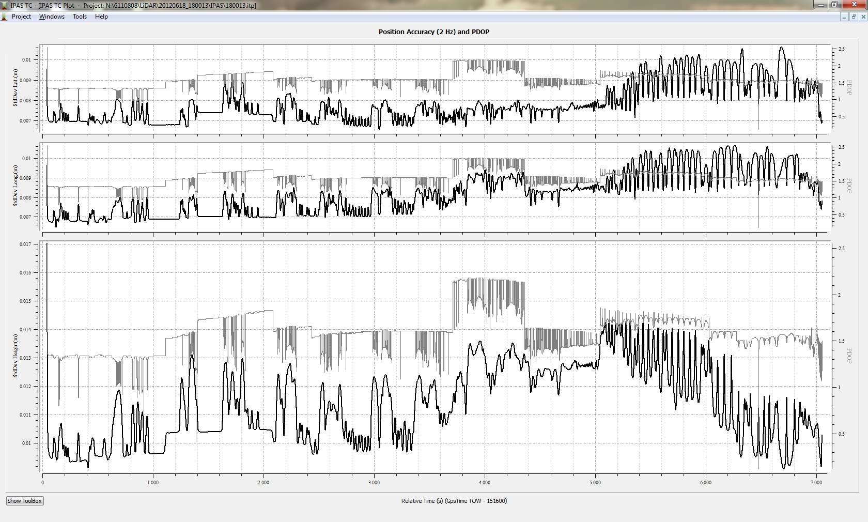

Figure 3.18: PDOP Plot 120618_180013

Distance from Base Plots

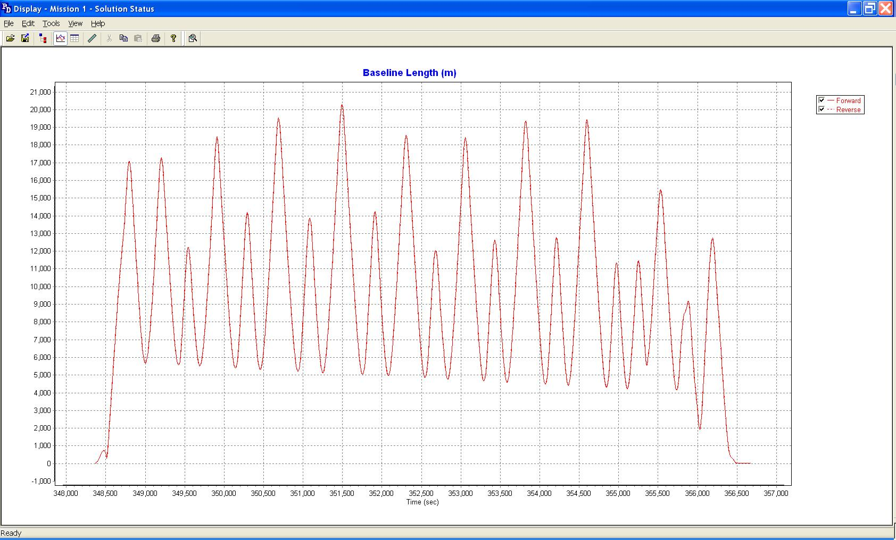

Figure 3.19: Distance from Base Plot M092111A

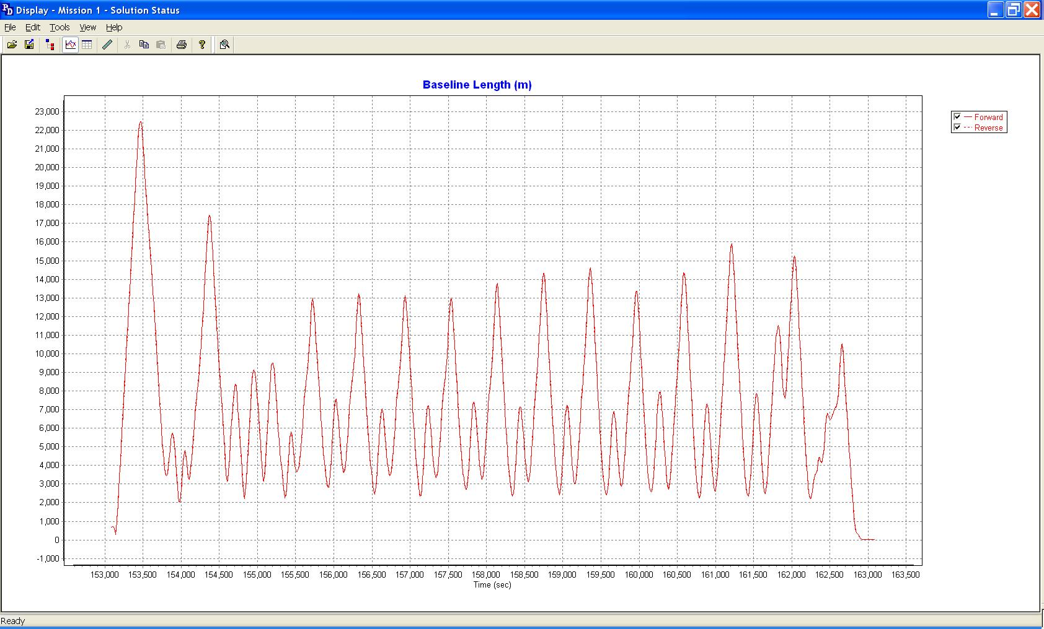

Figure3.20: Distance from Base Plot M092611A
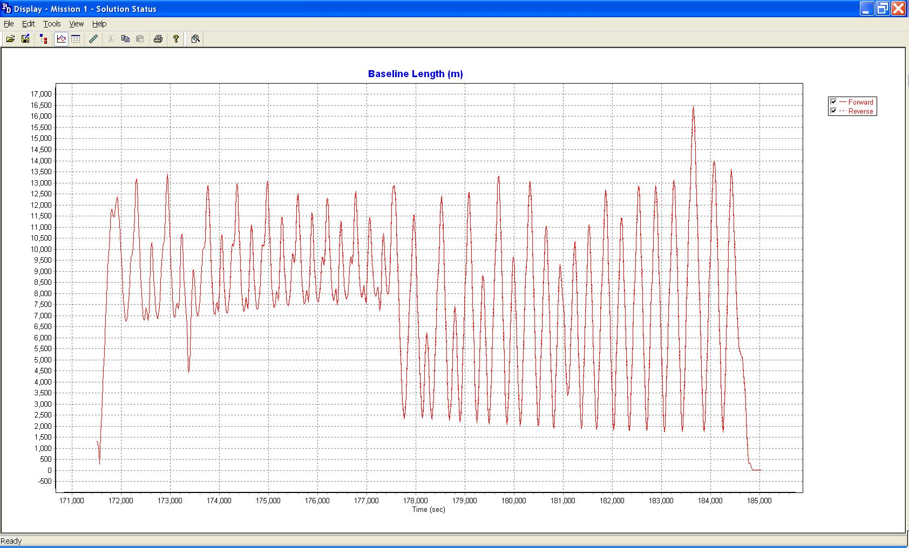

Figure3.21: Distance from Base Plot M092611B

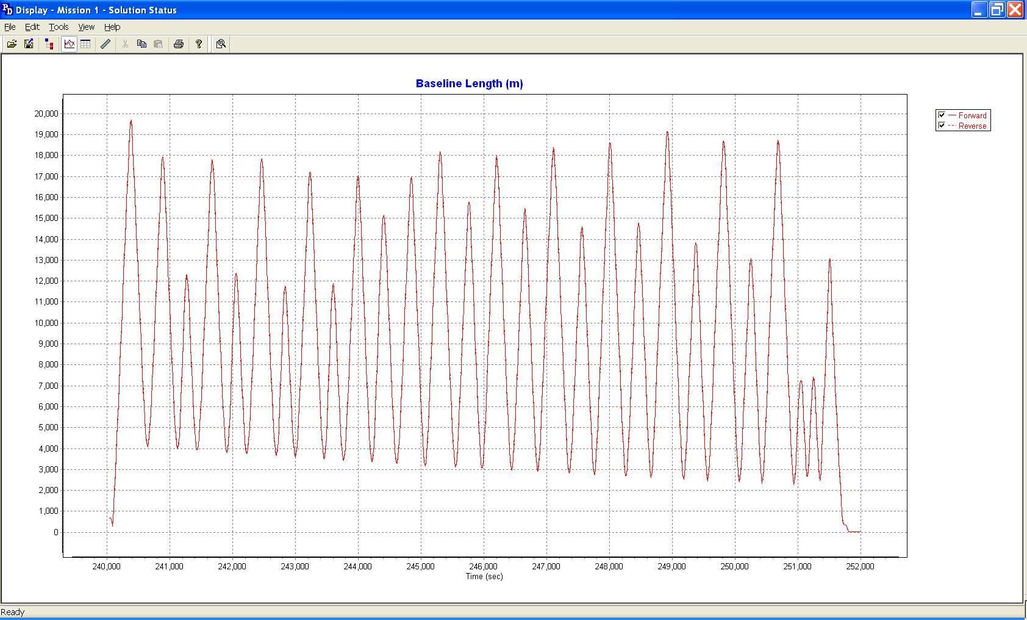

Figure3.22: Distance from Base Plot M101811A

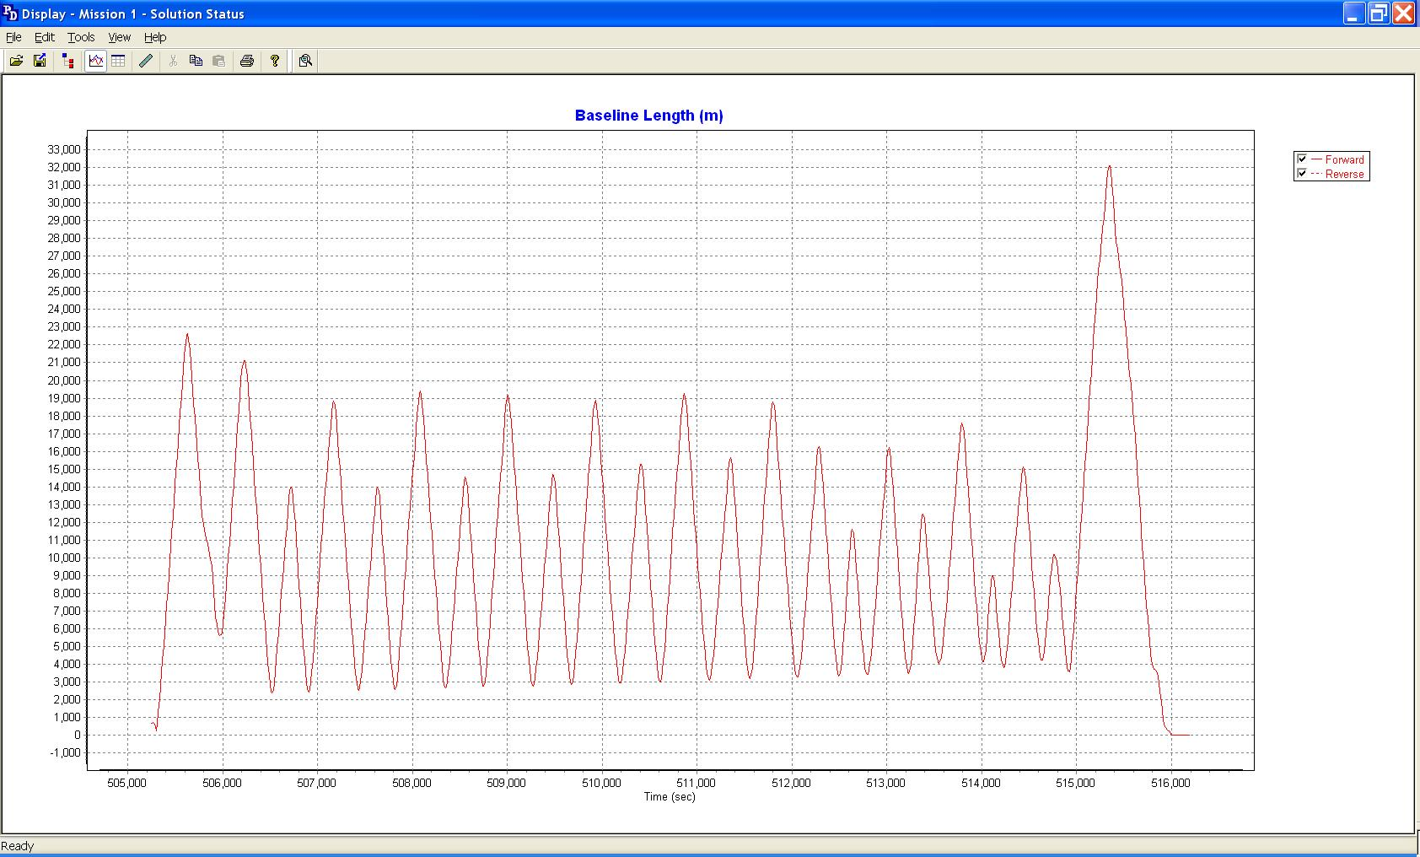

Figure3.23: Distance from Base Plot M102811A

Figure3.24: Distance from Base Plot 20120618_180013

3.2 Initial LiDAR Processing and Calibration

The airborne GPS and blending of inertial and GPS post-processing were completed in multiple steps.
- The collected data was transferred from the field data collectors to the main computer. Data was saved under the project number and separated between LiDAR mission dates. Inside each mission date, a sub-directory was created with the aircraft’s tail number and an A or B suffix was attached to record which mission of the day the data is associated with. Inside the tail number sub-directory, five sub-directories were also created: EO, GPS, IMU, PROC, and RAW.
- The aircraft raw data (IMU and GPS data combined) was run through a data extractor program. This separated the IMU and GPS data. In addition to the extraction of data, it provided the analyst the first statistics on the overall flight. The program was POSPac (POS post-processing PACkage).
- Executing POSGPS program to derive accurate GPS positions for all flights:
Applanix POSGPS
The software utilized for the data collected was PosGPS, a kinematic on-the-fly (OTF) processing software package. Post processing of the data is computed from each base station (Note: only base stations within the flying area were used) in both a forward and backward direction. This provides the analyst the ability to Quality Check (QC) the post processing, since different ambiguities are determined from different base stations and also with the same data from different directions.
The trajectory separation program is designed to display the time of week that the airborne or roving antenna traveled, and compute the differences found between processing runs. Processed data can be compared between a forward/reverse solution from one base station, a reverse solution from one base station and a forward solution from the second base station, etc. For the Applanix POSGPS processing, this is considered the final QC check for the given mission. If wrong ambiguities were found with one or both runs, the analyst would see disagreements from the trajectory plot, and re-processing would continue until an agreement was determined.
Once the analyst accepts a forward and reverse processing solution, the trajectory plot is analyzed and the combined solution is stored in a file format acceptable for the IMU post processor.

- When the processed trajectory (either through POSGPS) data was accepted after quality control analysis, the combined solution is stored in a file format acceptable for the IMU post processor (i.e. POSProc).
- Execute POSProc.

POSProc comprises a set of individual processing interface tools that execute and provide the following functions:
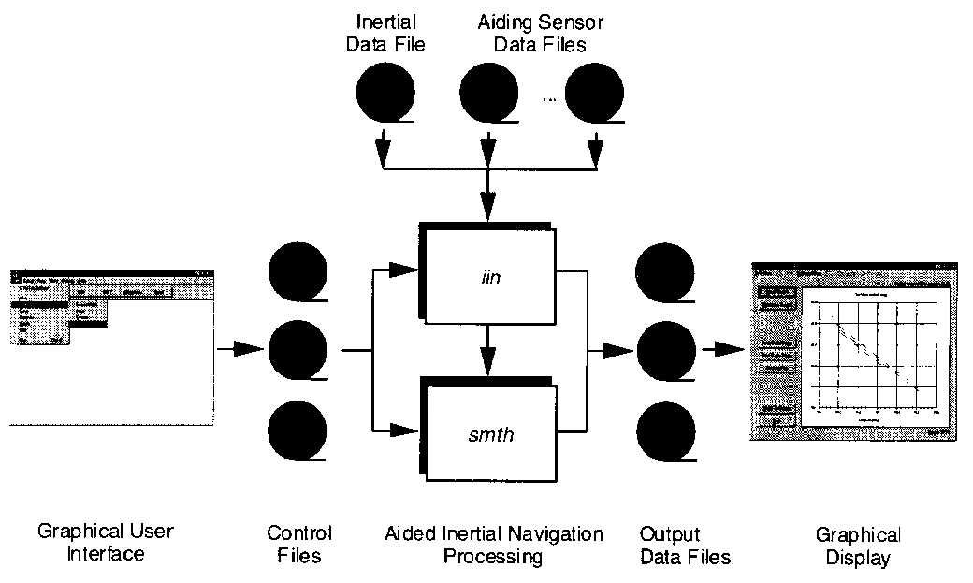Figure 3.25: POSProc Processing Components

Integrated Inertial Navigation (iin) Module.

The name iin is a contraction of Integrated Inertial Navigation. iin reads inertial data and aiding data from data files specified in a processing environment file and computes the aided inertial navigation solution. The inertial data comes from a strapdown IMU. iin outputs the navigation data between start and end times at a data rate as specified in the environment file. iin also outputs Kalman filter data for analysis of estimation error statistics and smoother data that the smoothing program smth uses to improve the navigation solution accuracy.
iin implements a full strapdown inertial navigator that solves Newton’s equation of motion on the earth using inertial data from a strapdown IMU. The inertial navigator implements coning and sculling compensation to handle potential problems caused by vibration of the IMU.
Smoother Module (smth)

smth is a companion processing module to iin. smth is comprised of two individual functions that run in sequence. smth first runs the smoother function and then runs the navigation correction function.
The smth smoother function performs backwards-in-time processing of the forwards-in-time blended navigation solution and Kalman filter data generated by iin to compute smoothed error estimates. smth implements a modified Bryson-Frazier smoothing algorithm specifically designed for use with the iin Kalman filter. The resulting smoothed strapdown navigator error estimates at a given time point are the optimal estimates based on all input data before and after the given time point. In this sense, smth makes use of all available information in the input data. smth writes the smoothed error estimates and their RMS estimation errors to output data files.
The smth navigation correction function implements a feedforward error correction mechanism similar to that in the iin strapdown navigation solution using the smoothed strapdown navigation errors. smth reads in the smoothed error estimates and with these, corrects the strapdown navigation data. The resulting navigation solution is called a Best Estimate of Trajectory (BET), and is the best obtainable estimate of vehicle trajectory with the available inertial and aiding sensor data.
The above mentioned modules provide the analyst the following statistics to ensure that the most optimal solution was achieved: a log of the iin processing, the Kalman filter Measurement Residuals, Smoothed RMS Estimation Errors, and Smoothed Sensor Errors and RMS.

3.3 LiDAR Calibration

The purpose of the LiDAR system calibration is to refine the system parameters in order for the post-processing software to produce a “point cloud” that best fits the actual ground.

For each mission, LiDAR data for at least one cross flight is acquired over the mission’s acquisition site. The processed data of the cross flight is compared to the perpendicular flight lines using either the Optech proprietary software or TerraSolid's TerraMatch software to determine if any systematic errors are present. In this calibration, the data of individual flight lines are compared against each other and their systematic errors are corrected in the final processed data.

3.4 LIDAR Processing
The LAS files were then imported, verified, and parsed into manageable, tiled grids using GeoCue.
After the data has been processed and calibrated a relative accuracy assessment is performed comparing flightline to flightline for proper position between flightlines. A data density test is also performed to ensure proper coverage. Aerometric uses GeoCue to create ortho images by elevation differences. The generated orthos have assigned elevation ranges that allow the technician to evaluate if the data passes the accuracy assessment and determine if additional calibration efforts are needed based on the bias trends. In Section 4, Figures 4-1 represent an example of the elevation orthos comparing neighboring flightline vertical positions. Green indicates a difference of less than 5cm; yellow is 5cm to 10cm; orange is 10cm to 15cm; and red is greater than 15cm. Areas containing dense vegetation coverage, or inundation from water will show as having higher elevation miss-match then is actually present in the ground data. This is because these regions have more point returns off objects and fewer returns from the ground making the miss match appear greater than it actually is.
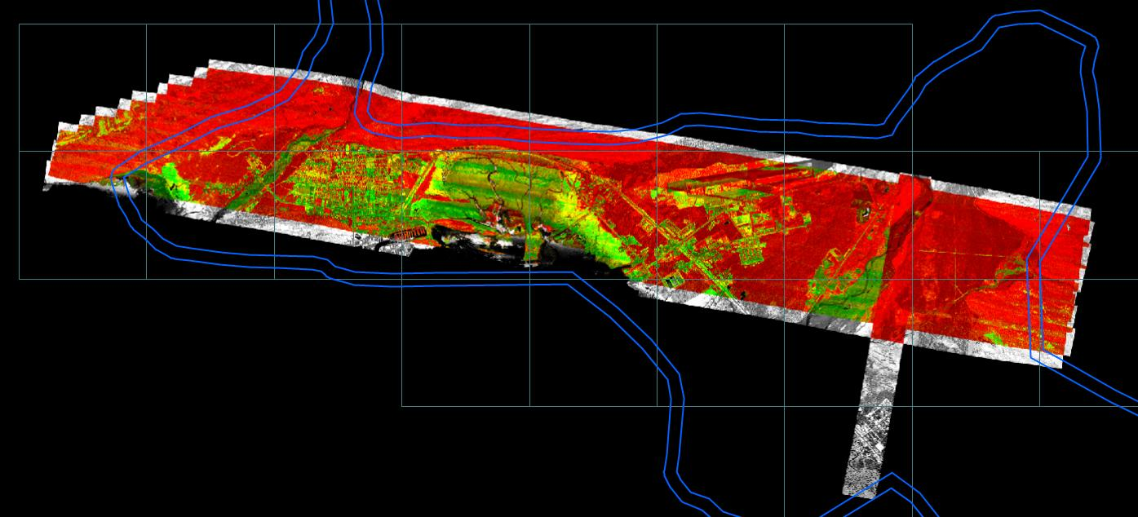
Figure 3.26: Example Dz Ortho

4.0 Final Accuracy Assessment

Data Verification:

The data was verified using the ground control data collected by Compass Data, Inc. 20 points were distributed throughout the project area and the points were compared to the LIDAR data using TerraScan. TerraScan computes the vertical differences between the surveyed elevation and the LiDAR derived elevation for each point.

Number Easting Northing Known Z Laser Z Dz
-----------------------------------------------------------------------
VAL101 547757.901 6771608.312 47.119 47.120 +0.001
VAL102 544527.346 6772495.157 8.491 8.570 +0.079
VAL103 543262.869 6773688.693 11.173 11.210 +0.037
VAL104 541867.525 6774337.270 10.538 10.490 -0.048
VAL105 542719.894 6777438.450 44.301 44.180 -0.121
VAL106 543689.812 6779111.216 72.300 72.360 +0.060
VAL107 540647.928 6776979.030 19.599 19.610 +0.011
VAL108 542321.641 6775040.070 16.412 16.420 +0.008
VAL109 539068.067 6776503.740 5.148 5.250 +0.102
VAL110 538229.178 6777412.460 4.999 5.000 +0.001
VAL111 537891.320 6777174.518 6.693 6.730 +0.037
VAL112 535975.746 6778375.971 5.724 5.830 +0.106
VAL113 534482.948 6776945.499 6.630 6.560 -0.070
VAL114 534461.085 6778212.145 16.968 16.980 +0.012
VAL115 534329.534 6780948.380 65.947 65.970 +0.023
VAL116 532150.658 6777732.386 5.883 5.850 -0.033
VAL117 532954.160 6778185.267 14.351 14.390 +0.039
VAL118 534130.630 6779266.061 48.005 48.080 +0.075
VAL119 534742.330 6782737.864 88.393 88.340 -0.053
VAL120 535615.081 6784561.818 139.320 139.300 -0.020

Average dz +0.012
Minimum dz -0.121
Maximum dz +0.106
Average magnitude 0.047
Root mean square 0.058
Std deviation 0.059

Table 4.1: Internal QC Control Results

Appendix A: Condensed Flight Logs

M092111A
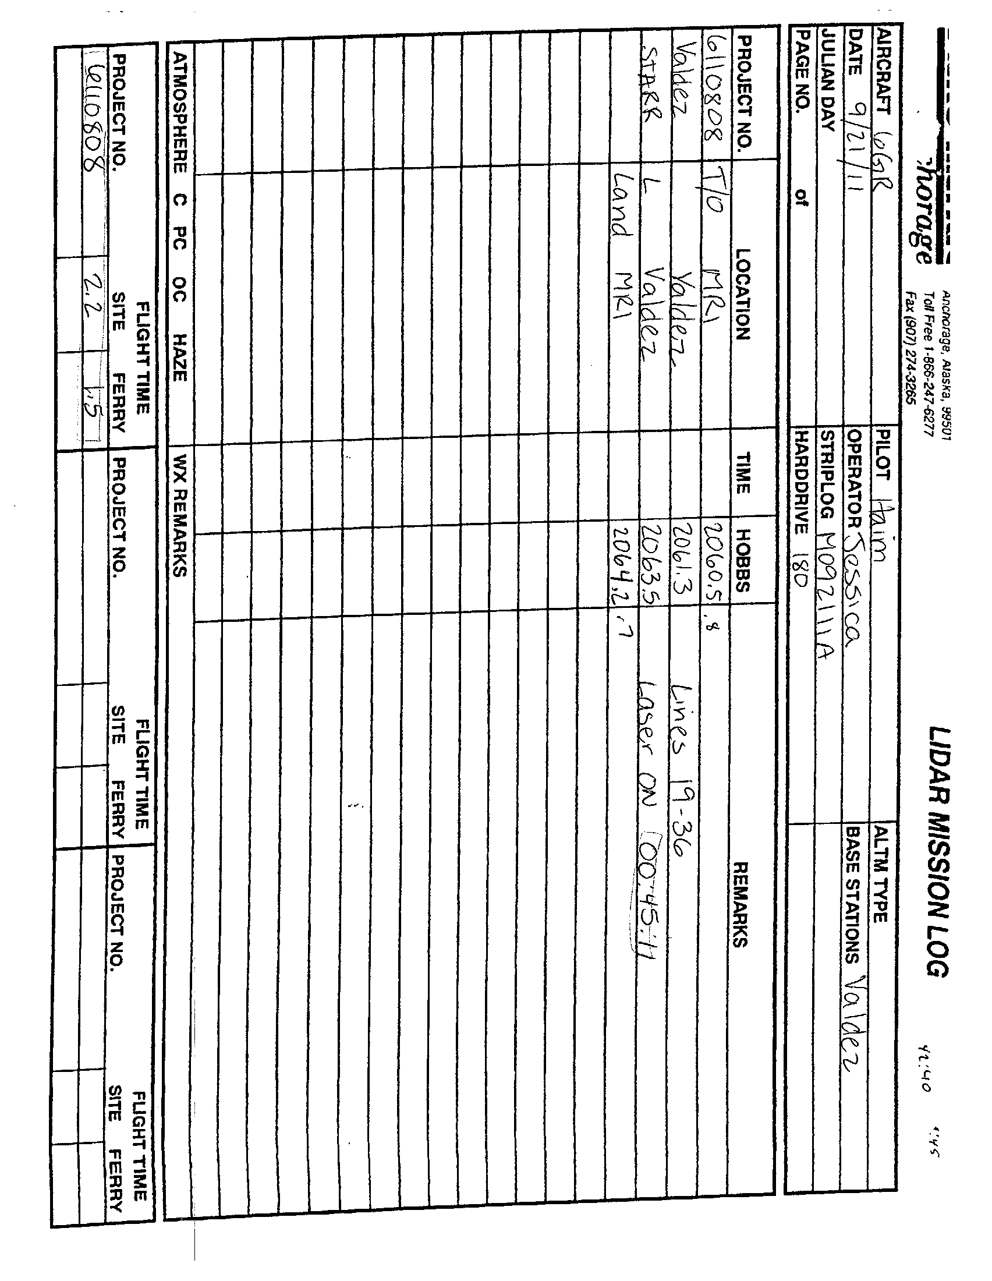

M092611A
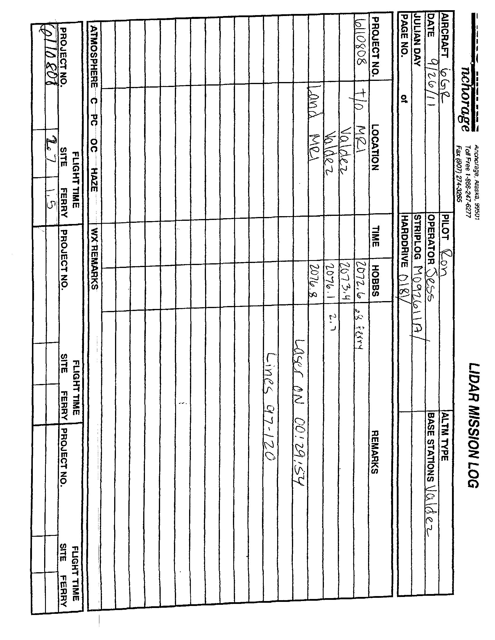

M092611B
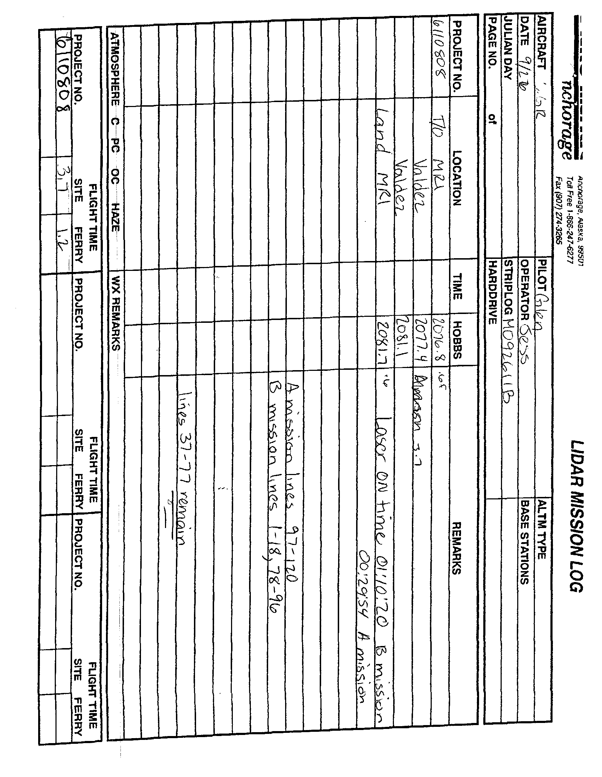

M101811A

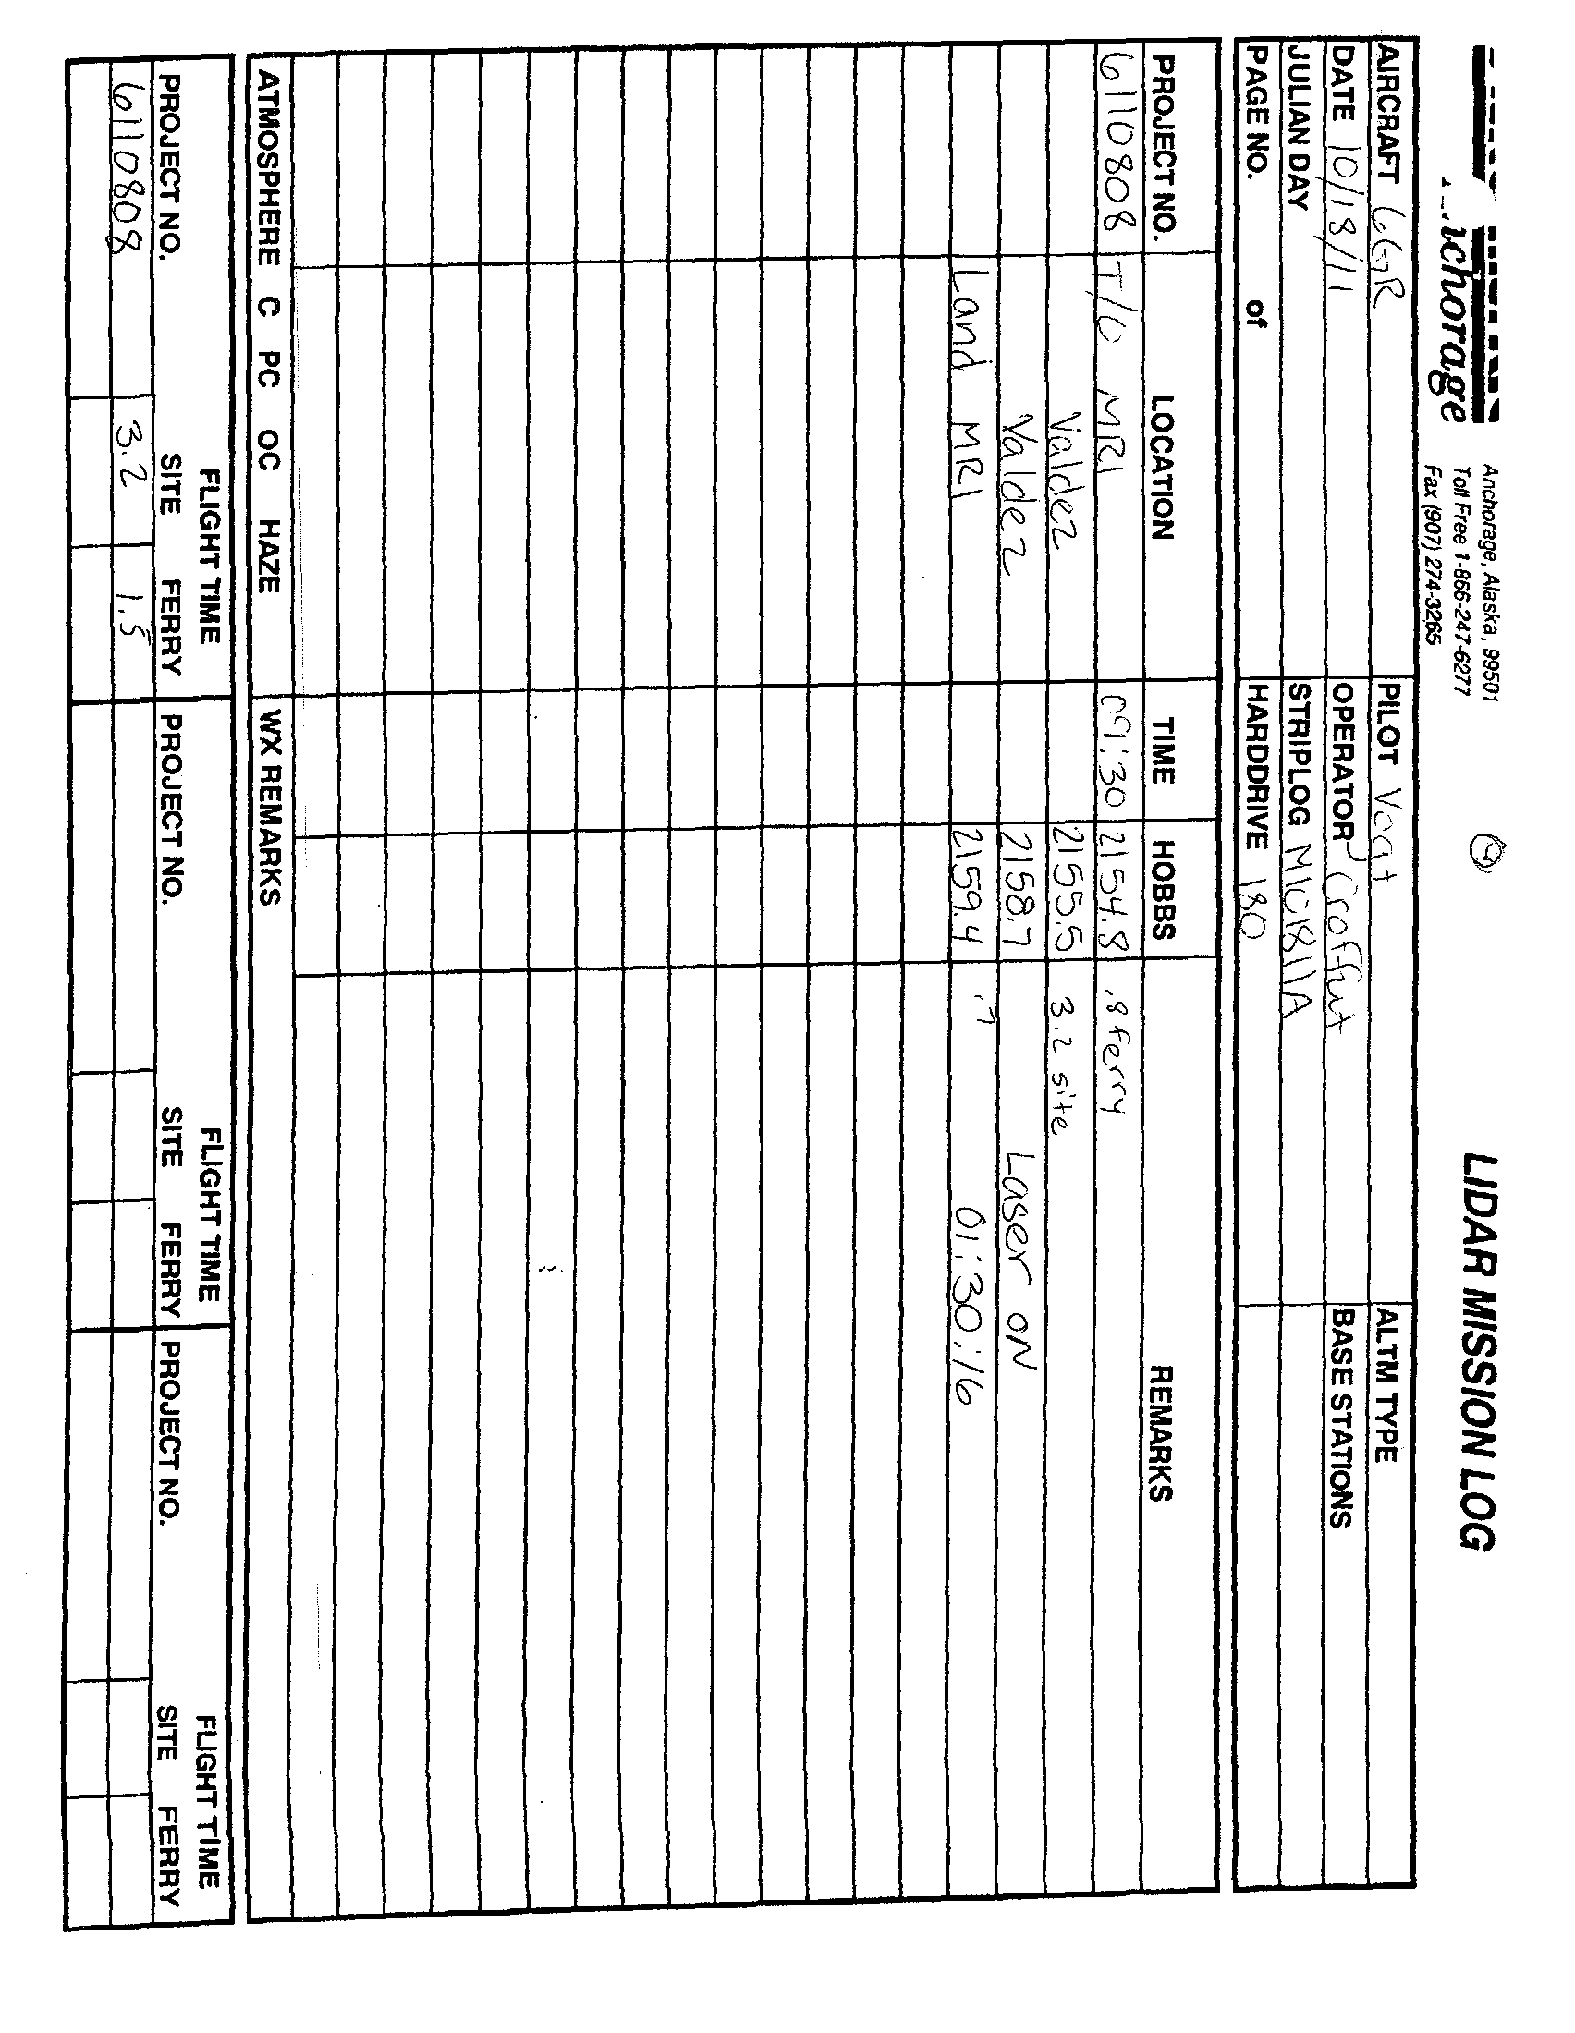

M102811A
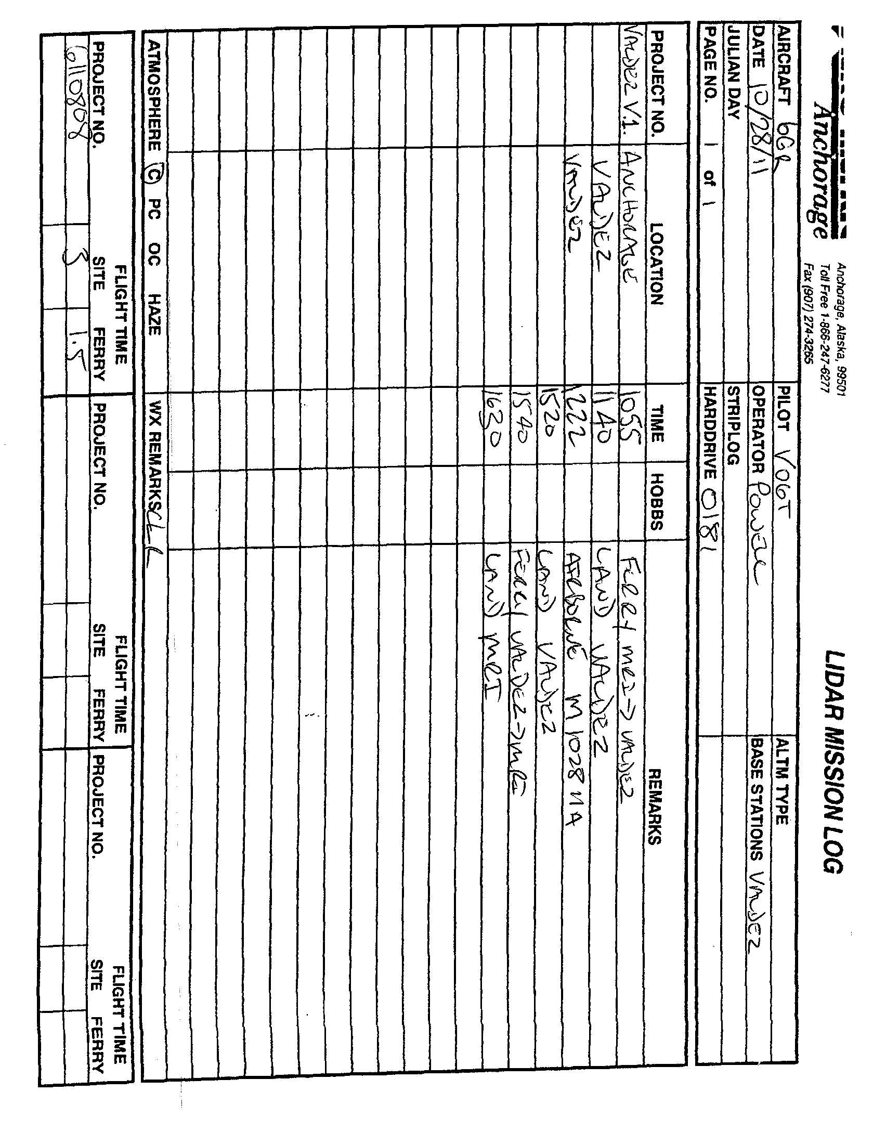

20120618_180013



