Lidar Report

for

Mobile Bay, Alabama

Contract Number: G10PC00026
Task Order: G10PD00578



May 26, 2010
Table of Contents

Project Description 1

Aerial Platform / Lidar Sensor 1

Flight Parameters 2

Dates Flown 3

Flight Line Layout 1

File Information 3

Projection / Datum 4

Base Stations Used 4

GPS Collection Parameters 5

Data Processing 5

QA/QC Analysis 6

Problems Encountered 7

List of Appendices (Reference Included Files)

Appendix A: Survey Report 9

Appendix B: Logs 9

Appendix C: System Calibration Reports 9

Appendix D: Aeroplan Sensor Report 9

Appendix E: Trajectory Report (by flight date) 9

Project Description
The purpose of this project is to provide professional surveying and mapping services for the creation of a high-resolution digital elevation model developed from LIDAR data for the Mobile Bay, AL project. The project area is shown in the graphic below.
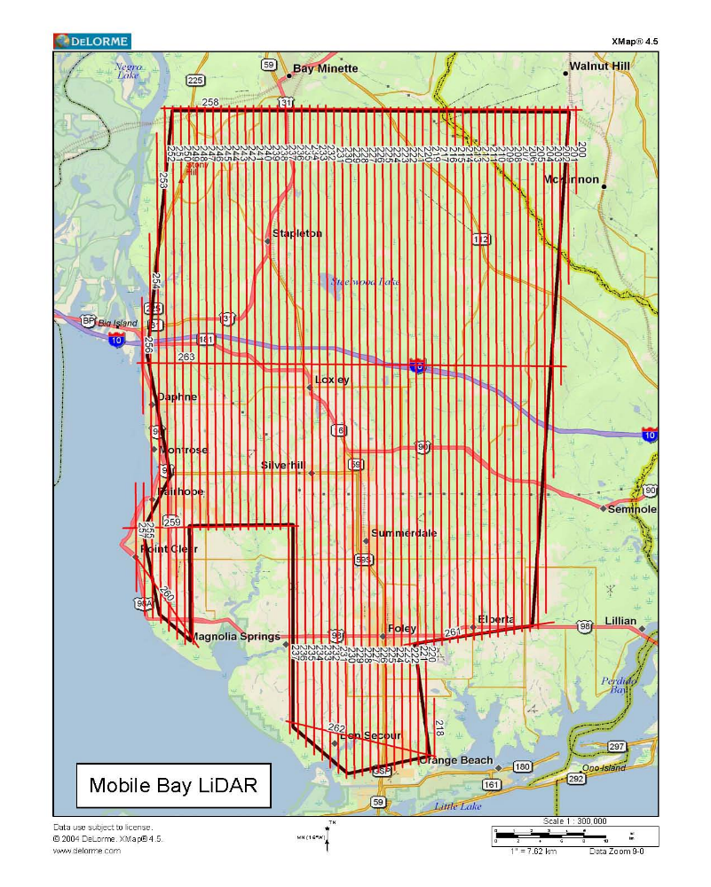

Aerial Platform / Lidar Sensor

All flights for the project were accomplished with customized single-engine Cessna 206s which provide an ideal, stable aerial base for Lidar acquisition. This platform has relatively fast cruise speeds that are beneficial for project mobilization / demobilization while maintaining relatively slow stall speeds which can prove ideal for collection of a high-density, consistent data posting.

Photo Science utilized an Optec Gemini LiDAR scanner on this project. the system is capable of collecting data at a maximum frequency of 167 kHz, which affords elevation data collection of up to 167,000 points per second. The system utilizes a Multi-pulse in the Air option (MPIA). This sensor is also equipped with the ability to measure up to 4 returns per outgoing pulse from the laser and these come in the form of 1st, 2nd, 3rd, and last returns. The intensity of the first three returns is also captured during the aerial acquisition.

See appendix C for system calibration information

Flight Parameters

Detailed project planning was performed for this project. This planning was based on project specific requirements and the characteristics of the project site. The basis of this planning included the required accuracies, type of development, amount and type of vegetation within the project area, the required data posting, and potential altitude restrictions for flights in the general area. A brief summary of the aerial acquisition parameters for this project are shown in the table below:

*******************Survey Totals*********************************
Total Passes : 108
Total Length : 2885.498 km
Total Flight Time : 31:19:45
Total Laser Time : 12:59:01
Total Swath Area : 480.609 km^2
Total AOI Area : 2599.193 km^2

Number of Sub-Areas : 1

*******************Area 1*********************************

Area Flight Profile
-----------------------------
Total Length : 2885.498 km
Flight Time : 31:19:45
Laser Time : 12:59:01
Swath Area : 480.609 km^2
AOI Area : 2599.193 km^2
Altitude : 1981.2 m AGL
Speed : 61.7 m/s
Flight Lines : 108
Pass Heading : 90
Pass Spacing : 166.56 m
Overlap : 40% = 1043.35 m
Turn Time : 5 min

Area LIDAR Settings
-----------------------------
Desired Res : 1.223 m
Density : 0.67 ppm^2
Cross Track Res : 1.226 m
Down Track Res : 1.22 m
Scan Frequency : 25.3 Hz
Scan Angle : +/- 17 deg
Scan Cutoff : +/- 0.02 deg
Scan Offset : 0 deg
System PRF : 50 kHz
Swath Width : 1209.91 m

Reference the Aeroplan sensor summary information included in Appendix D.

Dates Flown

All collection occurred as weather permitted between February 20th thru February 25th, 2010. Reference the flight logs and trajectory files included in Appendix B & E for graphical depictions and reports for each mission.

Flight Line Layout

As depicted above, a total of 108 flight lines were required to cover the project area.

File Information

The deliverable formats for the files are in the table below:

Classified LAS (918 – LAS Version 1.2 files)
Hydro Flattened Breaklines (1 – Arc Shapfile format)
Intensity Images (918 – GeoTIFF Images in TIF/TFW Format)
Metadata (16 XML files in 3 folders)
Project Level (1 file) By Lift (10 files) By Deliverable (5 files)
Project Report
Aeroplan | Survey Report
Control | System Calibration Report
CORS & Base Stationing | Trajectory
Flight Logs
Raster DEM (918 – 2 Meter DEM files in ERDAS IMG format)
Raw Flight Line Source (131 – LAS v1.2 Files in 10 folders)
Supporting Documentation
Flight Line Source folder
Project Level Tile Layout folder
Excel Spreadsheet (NGOM_Alabama_LiDAR_Las_Analysis_G10PD00578.xls)

Projection / Datum

The datum for all sites is UTM 16N horizontal and NAVD88 vertical, both in meters units.

Base Stations Used

ABGPS base stationing was established using Trimble 5700 data collection units, logging at 2 hertz, paired with Trimble Zephyr Geodetic antennas, which were mounted on variable height tripods with the H.I. measured at the beginning and end of each logging session. Stations included:
DL3486 ALDI DAUPHIN ISLAND CORS ARP
DI3826 AL90 ALDOT 9 DIV OFF CORS ARP
DL6167 MOB6 MOBILE POINT 6 CORS ARP
See Appendix F for CORS station values.

There are several limiting factors to LiDAR data collection which include:

Weather: there can be no clouds, excess moisture (rain, fog or excessive humidity) between the sensor and the ground we are profiling. Additionally, high winds which if blowing perpendicular to the line of flight could provide for excessive crab resulting in “slivers” or “holidays” between flight lines as well as unsafe flight conditions such as wind shear or clear air turbulence.

Ground Conditions: Such as standing water from recent heavy rains, excessive “ponding” or “pooling” of water which will affect the accuracy of the LiDAR returns as will snow and Ice. This is especially apparent in ditches with high water and along roadways and fence lines with drifting snow.

Satellite Configuration: Typically one does not want to collect LiDAR during time of high PDOP, this is due to the GPS configuration providing accuracy less than desired. For this project there is to be no data collection during periods of PDOP above 3.5 or periods with less than 6 visible satellites. To these ends, PDOP was checked each morning with a fresh almanac and newly updated satellite health status from the US Coast Guard Navigation Center website.

GPS Collection Parameters

Collection parameters for this project included the following:

Parameter | Value
Maximum PDOP | 3.5
Minimum number of SVs | 6
Ground collection epoch | 2 Hz (0.5 sec)

Data Processing

Optech software was used in the post-processing of the airborne GPS and inertial data that is critical to the positioning of the sensor during all flights. This software suite includes Applanix’s PosPac and Waypoint’s GrafNav solutions. PosPac provides the smoothed best estimate of trajectory (SBET) that is necessary for Optech’s post processor to develop the point cloud from the Lidar missions. The point cloud is the mathematical three dimensional collection of all returns from all laser pulses as determined from the aerial mission. At this point this data is ready for analysis, classification, and filtering to generate a bare earth surface model in which the above ground features are removed from the data set.

The point cloud was created using Optech’s Post Processor software. GeoCue was used in the creation of some of the files needed in downstream processing, as well as in the tiling of the dataset into more manageable file sizes. The TerraScan and TerraModeler software packages are then used for the automated data classification, manual cleanup, and bare earth generation from this data. Project specific macros were used to classify the ground and to remove the side overlap between parallel flight lines. All data was manually reviewed and any remaining artifacts removed using functionality provided by TerraScan and TerraModeler. QT Modeler was used as a final check of the bare earth dataset. GeoCue was then used to create the deliverable LAS 1.2 files for both the All Point Cloud Data and the Bare Earth. In-house software was then used to perform final statistical analysis of the classes in the LAS files.

Production QA/QC Analysis

A total of 22 points were established in the field for check points assessing the accuracy of the Lidar surface as depicted below. The additional table lists the statistics of this analysis of the survey control production points.

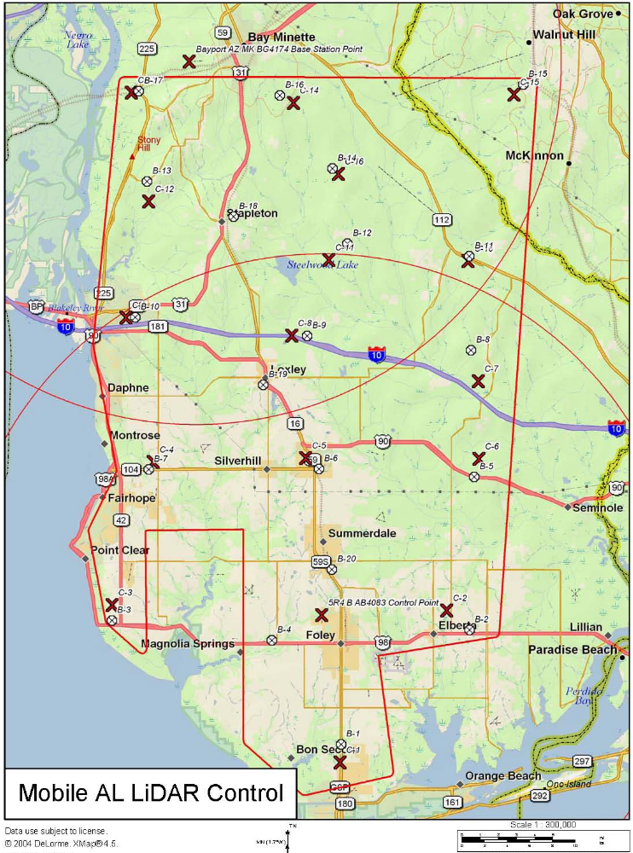
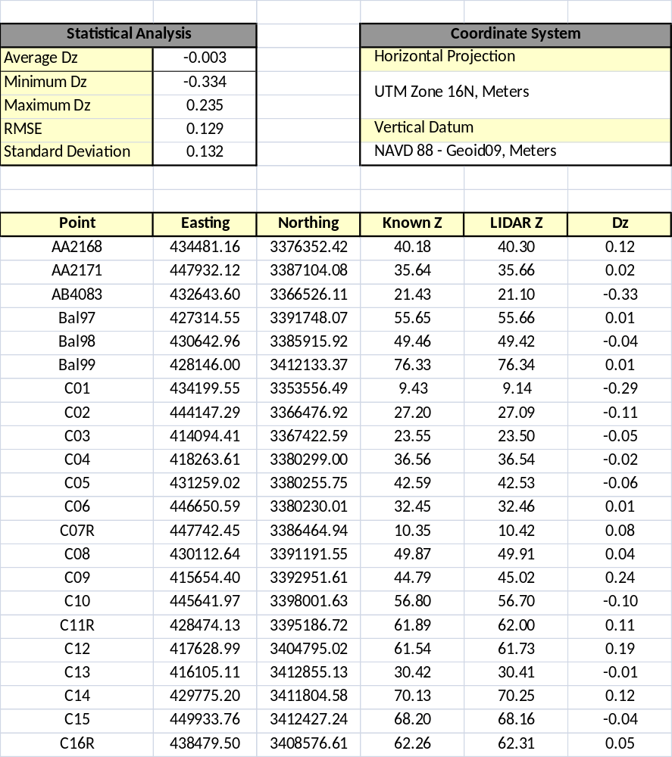

Problems Encountered

Problems encountered during this project were minimal. There were times of clouds, which is to be expected in a coastal environment. There were also a few times with winds outside what we consider an acceptable range. High cross winds result in crab and can minimize the overlap between adjacent flight strips. There were also some times with less than acceptable GPS configuration in terms of high PDOP or less than 6 satellites available for tracking. The crew checked the expected GPS configuration daily along with the weather and did not fly during less than ideal times. No issues were documented in the LAS tile development phase of production.

Appendix

Appendix A: Survey Report (Ref: Mobile_Bay_AL_Survey Report_G10PD00578 directory)

Appendix B: Logs (Ref: Mobile_Bay_AL _Flight Logs_ G10PD00578 directory)

Appendix C: System Calibration Reports (Ref: Mobile_Bay_AL _System_Calibration_Report_ G10PD00578 directory)

Appendix D: Aeroplan Sensor Report (Ref: Mobile_Bay_AL _Aeroplan_ G10PD00578 directory)

Appendix E: Trajectory Report by flight date (Ref: Mobile_Bay_AL _Trajectory Report_ G10PD00578 directory)

Appendix F: CORS and Base Station Reports (Ref: Mobile_Bay_AL _CORS & Base Stationing_ G10PD00578 directory)

