Point ID | BE022 |  |  | Aerial Target |  | Coordinate System
Project No. | R030675 |  |  | LiDAR Ground Control |  | NAD83(2011)
Project Name | Klamath Topobathy |  | X | LiDAR QC Point |  | UTM10
State | Oregon |  |  | New Control |  | NAVD88
County | Klamath |  |  | Photo ID |  | GEOID12B
Quad | Spencer Creek |  |  | Published Control |  | Meters

Northing | Easting | Elevation
4671818.559 | 576418.652 | 1191.368

Operator | Camden Beeghly |  | Date (MM-DD-YYYY) | 06-02-2018
Receiver Model | Trimble R8 |  | RMSE Hz
Receiver S/N | 5033444846 |  | RMSE Z
Antenna Height | 1.995m |  | GPS Method | RTK

PHOTOS:
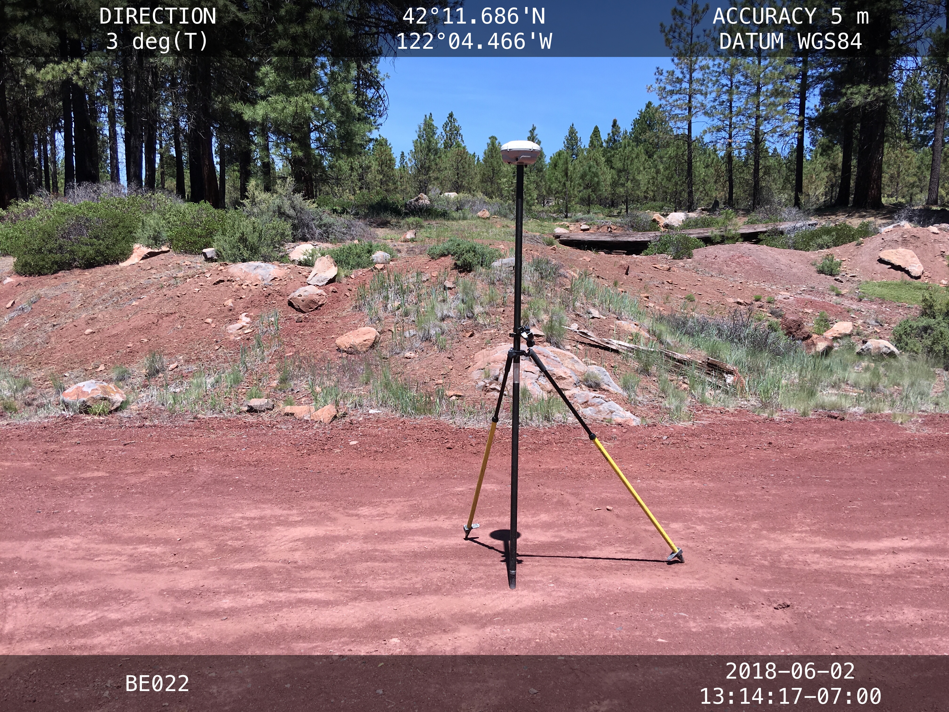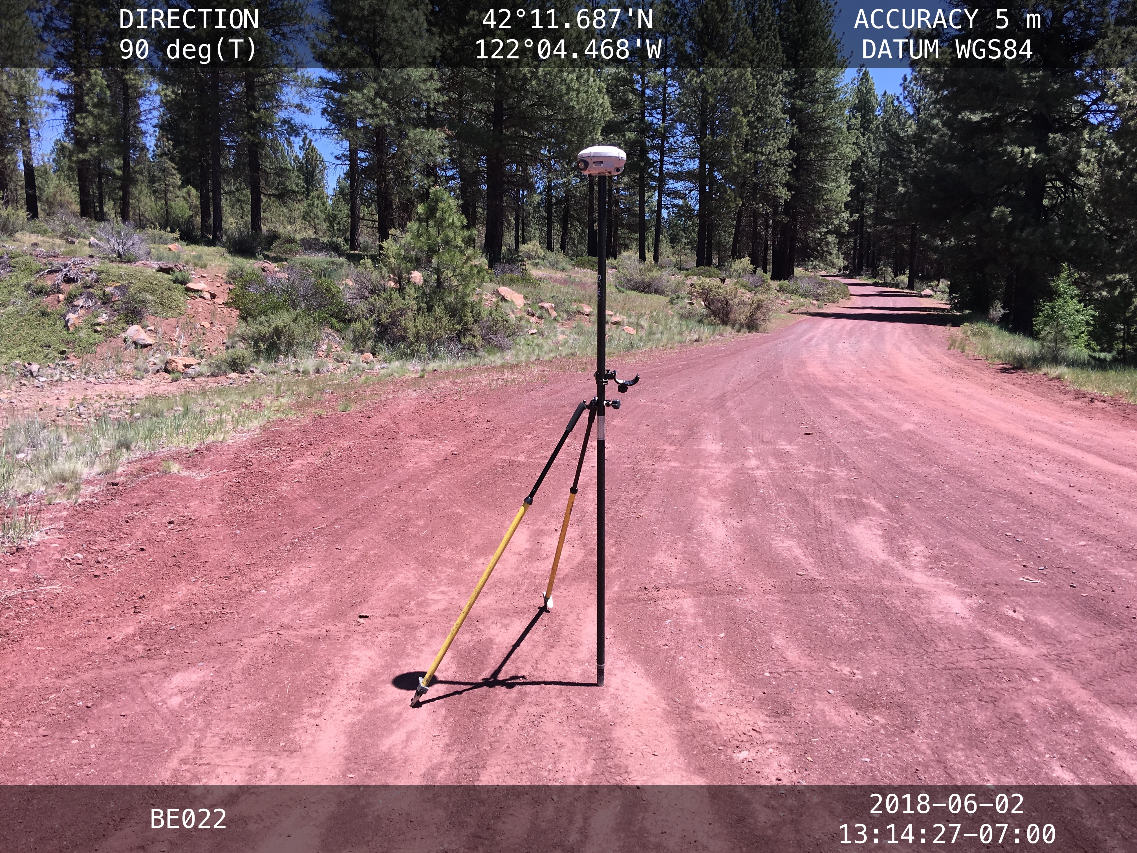 | 