FUGRO Geospatial, inc.

Accuracy Report – Ellicott City Collection

Prepared for:

United States Geological Survey
1400 Independence Road
Rolla, MO 65401
(573) 308-3689

January 28, 2019

USGS Contract: G17PC00015
USGS Task Order: 140G0218F0449

Accuracy reporting
Data collected under this Task Order meets the National Standard for Spatial Database Accuracy (NSSDA) accuracy standards. The NSSDA standards specify that vertical accuracy be reported at the 95 percent confidence level for data tested by an independent source of higher accuracy.

Positional Accuracy
Before classification and development of derivative products from the point cloud, the absolute and relative vertical accuracies of the point cloud were verified.

Absolute Vertical Accuracy
Unclassified Lidar Point Cloud Data: The Non-Vegetated Vertical Accuracy (NVA) of the Lidar Point Cloud data was calculated against TINs derived from the final calibrated and controlled swath data. The required accuracy (ACC_{Z}) is: 19.6 cm at a 95% confidence level, derived according to NSSDA, i.e., based on RMSE_{Z} of 10 cm in the “open terrain” and/or “Urban” land cover categories. This is a required accuracy. Please refer to the table below for the achieved accuracies. The raw swath point cloud data met the required accuracy levels before point cloud classification and derivative product generation. Image a
Table 1: Accuracy of the Lidar Point Cloud Data
Raw Flight Lines | RMSE_{Z} (non-vegetated) | NVA at 95-percent  confidence level
Specification (cm) | ≤ 10 | ≤ 19.6
Calculated Values (cm) | 2.7 | 5.3
Specification (m) | ≤ 0.100 | ≤ 0.196
Calculated Values (m) | 0.027 | 0.053
Number of points | 19 | 19

Excluded NVA Point: Of the 20 provided NVA points only 19 were usable. Due to the introduction of a vehicle into the Lidar data, NVA point MD-NVA-024 was excluded from the accuracy calculations and report. The vehicle was parked over the measured point which made accurate measurements impossible. This caused the calculations to skew towards a larger error. Once the point was removed from the calculation the RMSE returned to a significantly lower value. See image A and image B.

Image A: model of vehicle over measured NAV point 24:
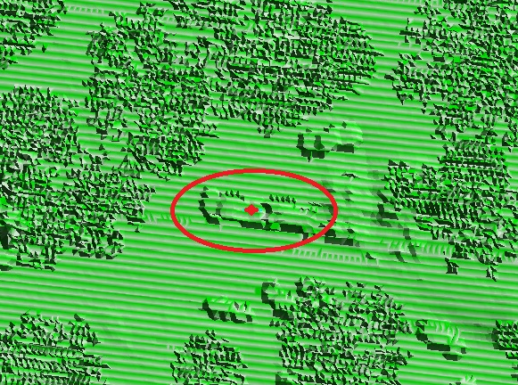

Image B: cross section of points over NAV point 24
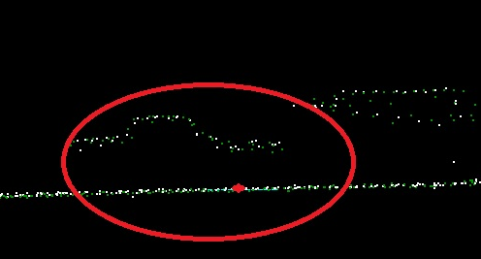

Bare Earth Surface: The accuracy (ACC_{Z}) of the derived DEM was calculated and is being reported in three (3) ways:
- RMSE_{Z} (Non-Vegetated): The required RMSE_{Z} is ≤ 10 cm.
- Non-Vegetated Vertical Accuracy (NVA): The required NVA is: ≤ 19.6 cm at a 95% confidence level, derived according to NSSDA, i.e., based on RMSE_{Z} of 10 cm in the “open terrain” and/or “Urban” land cover categories. This is a required accuracy.
- Vegetated Vertical Accuracy (VVA): The required VVA is: ≤ 29.4 cm at a 95th percentile level, derived according to ASPRS Guidelines, Vertical Accuracy for Reporting LiDAR Data, i.e. based on the 95th percentile error in Vegetated land cover categories combined (Tall Grass, Brush, Forested Areas). This is a required accuracy.

Please refer to the table below for the achieved accuracies.
Table 2a: Accuracy of the Derived DEM for State Plane Feet Delivery

DEM | RMSE_{Z} (non-vegetated) | NVA at 95-percent  confidence level | VVA at 95th percentiles
Specification (cm) | ≤ 10 | ≤ 19.6 | ≤ 29.4
Calculated Values (cm) | 3.9 | 7.6 | 6.1
Specification (m) | ≤ 0.100 | ≤ 0.196 | ≤ 0.294
Calculated Values (m) | 0.039 | 0.076 | 0.061
Number of points | 19 | 19 | 5

Table 2b: Accuracy of the Derived DEM for Albers Meters Delivery
DEM | RMSE_{Z} (non-vegetated) | NVA at 95-percent  confidence level | VVA at 95th percentiles
Specification (cm) | ≤ 10 | ≤ 19.6 | ≤ 29.4
Calculated Values (cm) | 3.5 | 6.8 | 8.3
Specification (m) | ≤ 0.100 | ≤ 0.196 | ≤ 0.294
Calculated Values (m) | 0.035 | 0.068 | 0.083
Number of points | 19 | 19 | 5

Relative Accuracy
Smooth Surface Repeatability: In ideal theoretical conditions, smooth surface repeatability is a measure of variations documented on a surface that would be expected to be flat and without variation. Users of lidar technology commonly refer to these variations as “noise.” Single-swath data was assessed using only single returns in non-vegetated areas. Repeatability was evaluated by measuring departures from planarity of single returns from hard planar surfaces, normalizing for actual variation in the surface elevation. Repeatability of only single returns was then assessed at multiple locations within hard surfaced areas (for example, parking lots or large rooftops).
Each sample area was evaluated using a signed difference raster (maximum elevation − minimum elevation) at a cell size equal to twice the ANPS, rounded up to the next integer. Sample areas were approximately 50 square meters (m²) or larger. The maximum acceptable variations within sample areas for this project is 6 cm. Isolated noise is expected within the sample areas and was disregarded.
The evaluation was done on 19 flat open sample areas over the entire Ellicott City collection AOI. The results are shown in the table below, please also refer to:

USGS_EllicottCity_Lidar_Relative_Accuracy_Smooth_Surface_Repeatability.shp
Table 3: Relative Accuracy, Smooth Surface Repeatability

Max_DZ | AREA sq m
0.0500 | 97.06
0.0560 | 97.88
0.0570 | 114.34
0.0570 | 77.03
0.0540 | 141.55
0.0600 | 57.81
0.0510 | 134.21
0.0490 | 105.80
0.0570 | 149.45
0.0600 | 262.41
0.0570 | 250.60
0.0600 | 382.75
0.0600 | 160.66
0.0580 | 128.53
0.0600 | 231.54
0.0570 | 107.95
0.0430 | 113.52
0.0580 | 130.59
0.0520 | 147.24

Overlap Consistency: Overlap consistency is a measure of geometric alignment of two overlapping swaths; the principles used with swaths can be applied to overlapping lifts and projects as well. Overlap consistency is the fundamental measure of the quality of the calibration or boresight adjustment of the data from each lift, and is of particular importance as the match between the swaths of a single lift is a strong indicator of the overall geometric quality of the data, establishing the quality and accuracy limits of all downstream data and products.
Overlap consistency was assessed at multiple locations within overlap in non-vegetated areas of only single returns.
Each overlap area was evaluated using a signed difference raster with a cell size equal to twice the ANPS, rounded up to the next integer. The difference rasters are visually examined using a bicolor ramp from the negative acceptable limit to the positive acceptable limit. Although isolated excursions beyond the limits are expected and accepted, differences in the overlaps shall not exceed the following limits:
- Swath overlap difference, RMSDz ≤ 8 cm
- Swath overlap difference, maximum ± 16 cm

The difference rasters are also statistically summarized to verify that root mean square difference in z (RMSDz) values do not exceed the 8 cm maximum. Consideration will be given for the effect of the expected isolated excursions over limits.
The result of the evaluation over 37 samples throughout the entire Ellicott City collection AOI is shown in the table below, please also refer to:
USGS_EllicottCity_Lidar_Relative_Accuracy_Flightline_Overlap.shp
Table 4: Relative Accuracy, Overlap Consistency
RMS_DZ | Max_DZ | Min_DZ | Shape_Area
0.0194 | 0.0626 | -0.0644 | 437.42
0.0212 | 0.0547 | -0.0666 | 443.55
0.0401 | 0.0109 | -0.0859 | 486.08
0.0153 | 0.0523 | -0.0254 | 584.26
0.0169 | 0.0451 | -0.0417 | 540.70
0.0185 | 0.0686 | -0.0440 | 405.47
0.0213 | 0.0573 | -0.0268 | 455.91
0.0190 | 0.0337 | -0.0554 | 411.73
0.0239 | 0.0998 | -0.1061 | 430.69
0.0265 | 0.0558 | -0.0916 | 446.54
0.0173 | 0.0273 | -0.0479 | 466.67
0.0501 | 0.0162 | -0.1563 | 457.41
0.0142 | 0.0320 | -0.0529 | 2944.03
0.0189 | 0.0706 | -0.0765 | 1928.39
0.0254 | 0.0214 | -0.0628 | 413.28
0.0183 | 0.0440 | -0.0590 | 903.51
0.0118 | 0.0456 | -0.0442 | 1309.18
0.0119 | 0.0410 | -0.0463 | 1596.36
0.0241 | 0.0682 | -0.0292 | 568.35
0.0270 | 0.0890 | -0.0416 | 629.82
0.0215 | 0.0364 | -0.0740 | 817.51
0.0150 | 0.0505 | -0.0408 | 584.48
0.0211 | 0.0456 | -0.0871 | 1073.22
0.0170 | 0.0604 | -0.0580 | 888.81
0.0158 | 0.0634 | -0.0456 | 826.22
0.0164 | 0.0543 | -0.0327 | 1516.10
0.0223 | 0.0974 | -0.0453 | 591.62
0.0190 | 0.0519 | -0.0627 | 443.13
0.0192 | 0.0539 | -0.0249 | 857.34
0.0231 | 0.0550 | -0.0751 | 743.72
0.0113 | 0.0445 | -0.0395 | 1131.90
0.0205 | 0.0599 | -0.0244 | 588.43
0.0166 | 0.0591 | -0.0733 | 726.80
0.0202 | 0.0238 | -0.0536 | 570.16
0.0193 | 0.0209 | -0.0505 | 601.23
0.0143 | 0.0434 | -0.0872 | 666.23
0.0253 | 0.0199 | -0.0661 | 852.63

